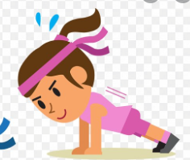

Choose Your Own Workout

Live and Learn Sports KS2

20 PUSH UPS

30 SQUATS

35 STAR JUMPS

1 MIN JOG

ON SPOT

30 LUNGES

30 SEC

FORWARD FOLD POSE

30 SEC SEAL POSE

35 MOUTIN CLIMBERS

40 HIGH KNEES

35 SKATERS

30 SQUATS

25 SKI JUMPS

40 HEEL FLICKS

30 SEC BUTTERFLY SIT

30 SEC BUTTERFLY SIT

25 SQUAT JUMPS

25 SQUATS

30 SECOND CHILDS POSE

1 MIN JOG ON THE SPOT

30 SECOND FORWARD FOLD

30 SECOND LOW LUNGE TWIST

5 min Warm up - Including static and dynastic stretches and lifting the heart rate ready to work.

30 MOUNTIN CLIMBERS

30 SEC SQUAT THRUSTS