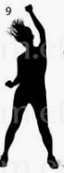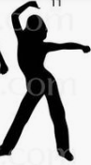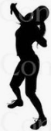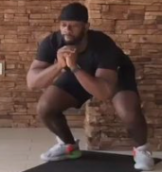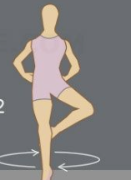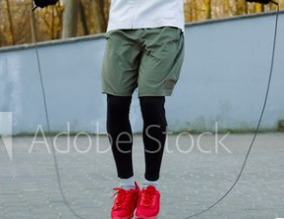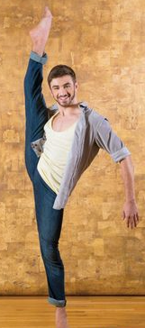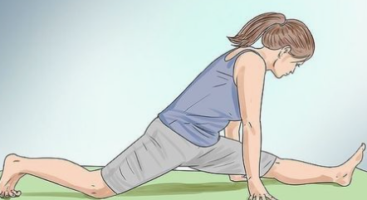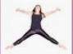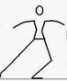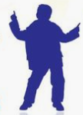

21 Basic Dance Moves

Live and Learn Sports

STEP CLAP: Step side to side clapping your hands

ROLL YOUR ARMS:

in front of your chest.

SLIDE: Step side to side dragging your back leg.

ARABESQUE:

KNEE LIFT: Lift one knee at a time try to bounce as you do it.

REACH: Any direction, use both arms.

JUMP ONE FOOT TO ANOTHER:

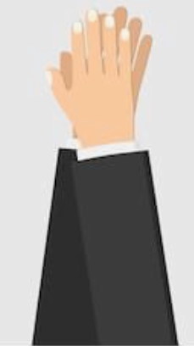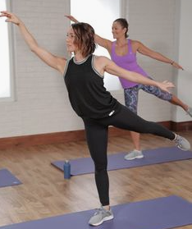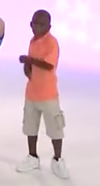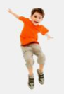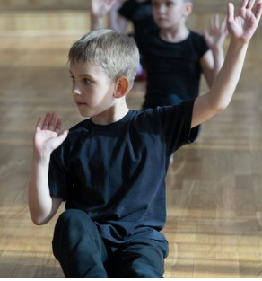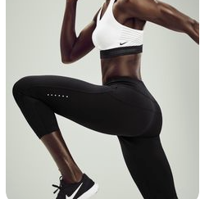

SHOULDERS: Push your shoulders up and down, with your arms.

LOOK:

Turn your head to one side and then another.

STEP STEP: Step your right foot then left, get ready for the next move.

KICK: Forward making sure your in a space.

RUN AND PUNCH: In pace pushing our arms forward.

SQUAT JUMP: Any direction, to change direction.

SKIP: We use this to move places.

SPLITS: As far down as you can in the splits.

EXPLODE:

Jump your body out as far as you can.

TWIST: Move your feet one way and arms another.

SHAKE: Lean your body forward and back and shake.

STOMP: Feet together jump forward and back whilst punching one arm to the sky.

SWIM: Make a swimming motion with your arms.

TURN RIGHT AND LEFT: