Unfortunately, suicide among children & young people is one of the leading causes of death in the UK, accounting for 14% of deaths in 10-19 year olds. Despite the UK having a low rate of suicide compared to other countries, there has been an increase in recent years. Additionally, the UK has seen a rise in children & young people self-harming in the last 15 years.

2. Why it matters

Suicide in Children and Young People

Live and Learn Sports

Safeguarding Children

Partnership 2020

Suicide is defined as a deliberate act that is intended to ends one’s life. Over half of young people who die by suicide have a history of self-harm. Self-harm has risen in the last 15 years—in 2014, one in five young women reported having ever self-harmed, twice the rate in young me. Given the worrying statistics in relation to suicide and self-harm, the UK government have made improving the mental well-being a priority.

1. Background

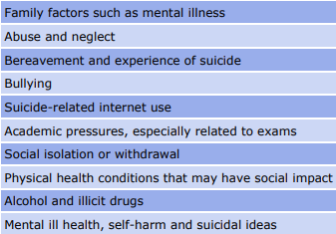

3. Information – Common themes

• Recognise that any child or young person who has self-harming behaviour is communicating their very real need for attention or help

• Recognise the pattern of cumulative risk and “final straw” stresses that can lead to suicide

• Act up & follow through on any concerns. Remember…EVERY CHILD MATTERS!

7. What to do =

RSCB

Rotherham Safeguarding Children Board –

7-minute Briefing

• Do I understand the risk factors?

• Am I clear about my role in suicide prevention?

• Do I know where to access specialist advice?

• Who do I contact in my school if I have concerns about a child?

• Do I know my school’s policy on dealing with concerns?

6. Questions

Vulnerable groups

• Children & young people who are bereaved

• Children & young people with a history of self-harming

• LGBT children who have fears of disclosing their sexuality or gender identity

5. Information

Suicide in young people is rarely caused by one thing; it usually follows a combination of previous vulnerability and recent events. Important themes for suicide prevention are support for or management of family factors (e.g. mental illness, physical illness, or substance misuse), childhood abuse, bullying, physical health, social isolation, mental ill-health and alcohol.

4. Information