Iron Man Workout to Music

Information: If you are completing this workout with others, please ensure you are 2 m away from each other. Stick on some music and carry out each activity for 45 seconds with 30 seconds rest in between each one. Repeat the routine 2/3 times. Get ready…and off you go!
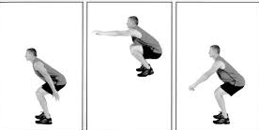
1. Power Skipping 2. Repeated Tuck Jumps

3. Burpees 4. Repeated Pike Jumps
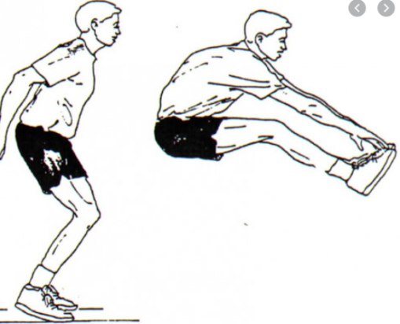
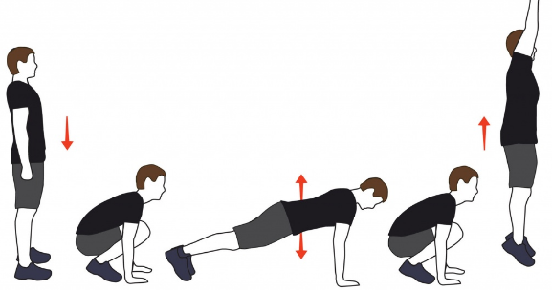

5. Squat Jumps 6. Mountain Climbers

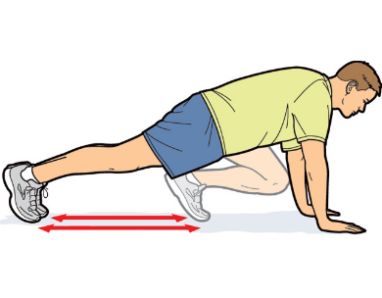
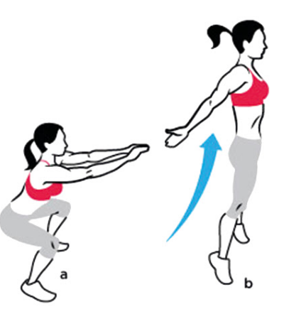

7. Star Jumps 8. Lunge Jumps
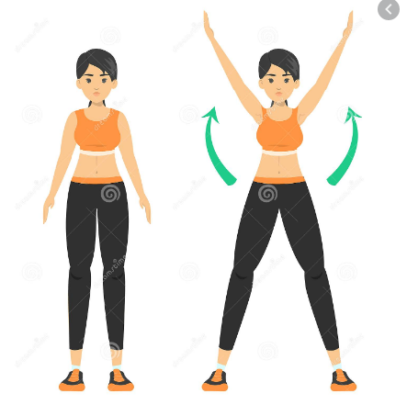

9. Vertical Power Jumps 10. Single Leg Vertical Power Jumps
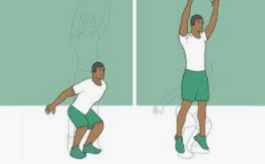
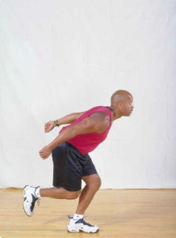

11. Speed Bounce 12. Plank Hops
