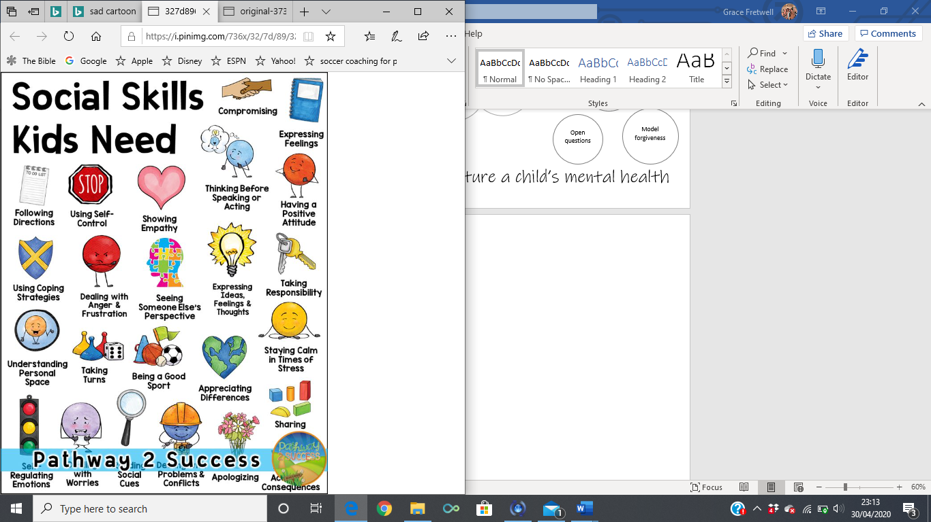







How to nurture a child’s mental health