GROWTH MINDSET
Practice makes Permanent
Try different ways of doing things
A challenge is an opportunity!
Don’t compare yourself to others, Learn from them!
Ask if you don’t understand
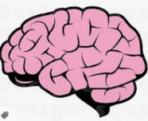
Share your ideas and learning
Think outside the box
Believe in yourself
Work hard Be kind to others

Use your creativity
Set achievable targets
Focus on your effort
How do you improve?
Exercise your brain
Don’t give up, Be proud
I can’t do this…YET!
It’s LEARNING not FAILING
Take ownership of your attitude
Learn from other people’s mistakes
Be resilient!
You have some weaknesses…So does everyone else!

