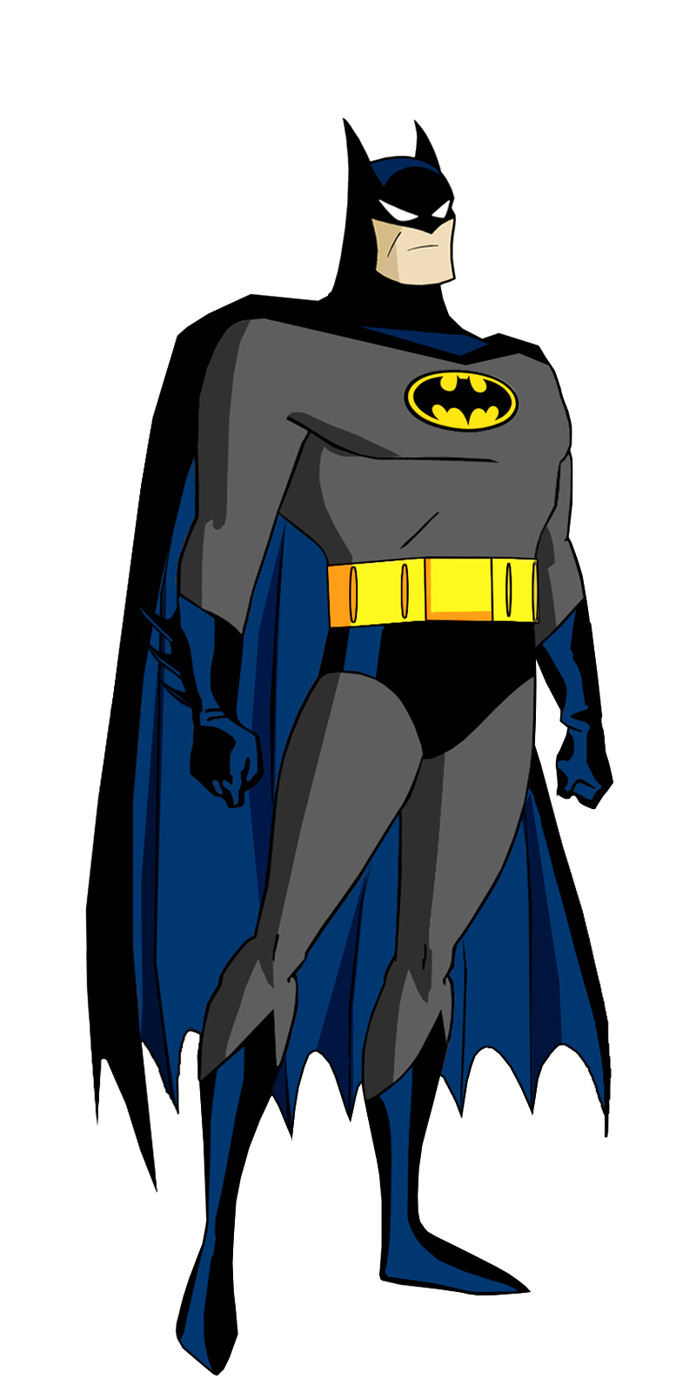
BatMan Workout to Music

Information: For this workout, you will need a bend or box to help you complete. If you are completing this workout with others, please ensure you are 2 m away from each other. Stick on some music and carry out each activity for 45 seconds with 30 seconds rest in between each one. Repeat the routine 2/3 times. Get ready…and off you go!
1. Repeated Straddle Jump 2. Power Step Up
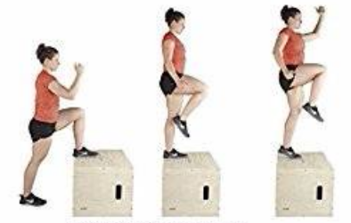
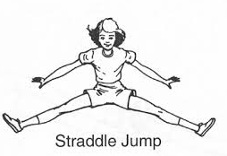

3. Box / Bench Jump 4. One Leg Box / Bench Jump
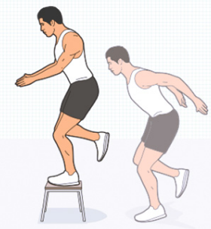
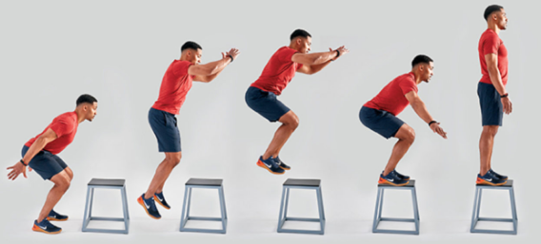

5. Reactive Drop Jumps 6. Jump over Bench
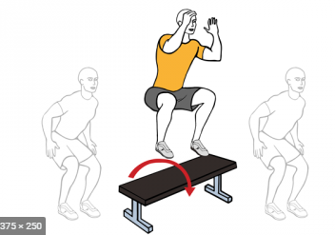

7.Standing Long Jump 8. Flying Skaters
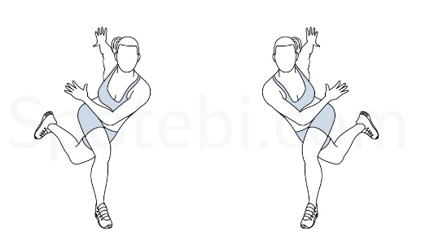
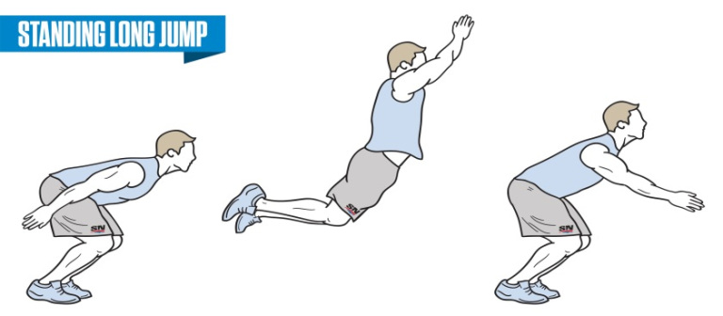

9. Front Kicks 10. Forward Push Up
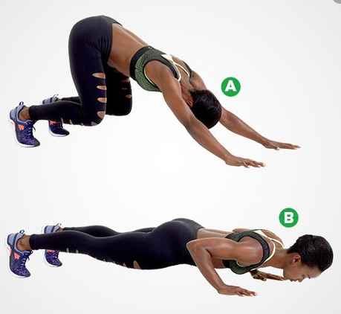
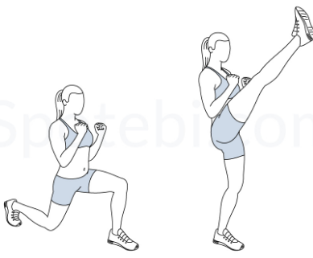

11. Forward Push Up 12. Power Skipping
