****24 WAYS TO IMPROVE MENTAL HEALTH

Do Your Best!

Meditate

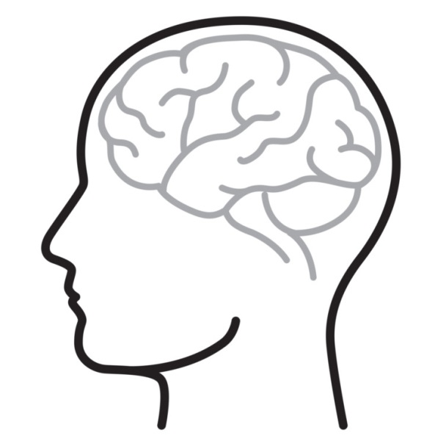

Try Something New

Try Something New

Be kind to yourself

Practice Deep Breathing

Avoid comparing yourself to others

Go Outdoors

Help Others

Eat Well

Make chores fun to do

Try and keep busy

Do tasks that you’re good at

Ask for help

Keep a log/ Journal

Make time for yourself

Set Goals

Listen to Music

Share Things

Exercise

Challenge Thoughts

Use good posture and body language

Take social media and phone breaks

Rest Well