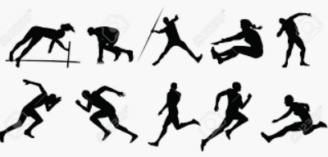
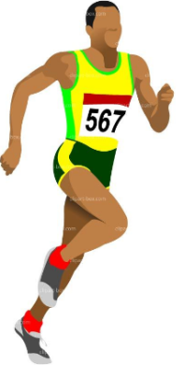
Parent comment:
L & L Sports Track and Field Athletics
Home Learning Pack
- Olympics Quiz
- Weekly Exercise Plan
- Commentator Challenge
- Round the World Stretching
- Athlete Training Activity
- The Human Body
- Athletics Word Search
- Track & Field Drills (Running)
- Track & Field Drills (Throwing)
- Track & Field Drills (Jumping)
- Athlete Fact File

Useful websites
https://www.britishathletics.org.uk/athletes/
https://www.youtube.com/channel/UCAxW1XT0iEJo0TYlRfn6rYQ

KS2 BBC Bitesize

Useful Vocabulary
Athletics training Olympics
Muscles Commentary Athlete

Teacher comment:
L & L Sports Track and Field Athletics
Olympic Quiz
- How many rings are there on the Olympic flag?

- The Modern Olympic Games are based on the Olympic Games of which ancient country?

- If gold medals are awarded for first place and silver for second, which medal is awarded for third?

- An Olympic-size swimming pool is how many metres long in length?

- The Olympic Games are held every how many years?

- Which country has won more medals in total than any other nation at the Summer Olympic games?

- Which city hosted the Summer Olympics in 1908, 1948, and 2012? It's the only city to host the event on three occasions.

- The 2020 Summer Olympics should’ve been held in which city?

- Out of all the Summer Olympic sports which sport comes first alphabetically?

- Which British rower won a rowing gold medal in five different Olympic Games?

L & L Sports Track and Field Athletics
Weekly Exercise Plan

Monday | Tuesday | Wednesday | Thursday | Friday
M = 5 Sit ups  O = 5 Burpees  N = 20 Star jumps  D= 5 Push ups  A = 20 Sec plank  Y = 5 Squat Jumps | T= 20 Sec wall sit  U = 6 Sit ups  E = 30 Sec jog on spot  S = 25 Sec plank  D = 6 Burpees  A = 6 Push ups  Y = 6 Squat jumps | W= 10 jump and touch sky  E= 30 Sec jog on spot  D= 25 Star jumps  N= 7 Push ups  E= 25 Sec plank  S= 25 Star jumps*  D= 7 Burpees  A= 7 Squat humps  Y= 7 Sit ups | T= 20 Sec wall sit  H= 8 Sit ups  U= 25 Sec plank  R= 30 Star jumps  S= 8 Push ups  D= 8 Burpees  A= 8 Jump squats  Y= 10 Jump and touch sky | F= 30 sec wall sit  R= 10 Sit ups  I= 10 Push ups  D= 10 Burpees  A= 10 Jumps squats  Y= 35 Star jumps

Rest for 1 minute in between each activity
If you haven’t done so already, check out The Body Coach TV for a morning work out!
https://www.youtube.com/channel/UCAxW1XT0iEJo0TYlRfn6rYQ

L & L Sports Track and Field Athletics
Commentator Challenge
Test your skills as an Athletics commentator! This is the 200 m men’s final from the Rio Olympic games in 2016. Watch this clip and record your own commentary. Could you use sports specific language?
1st Place 2nd place 3rd place Leading the way Great start
World record
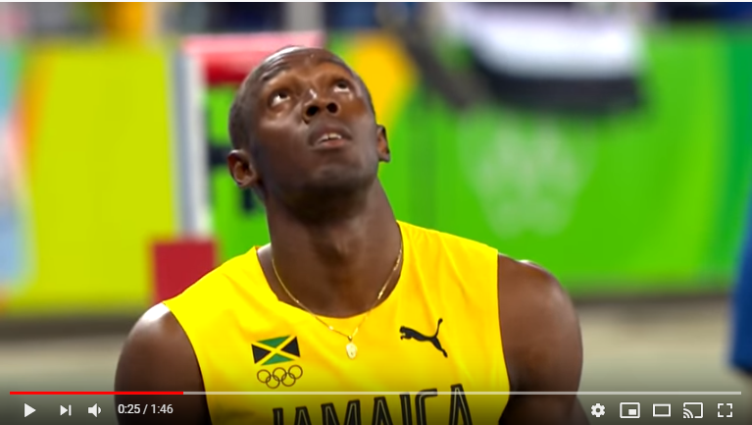
You can find the clip here: https://www.youtube.com/watch?v=pWVyIE30bPs

L & L Sports Track and Field Athletics
Round the World Stretching
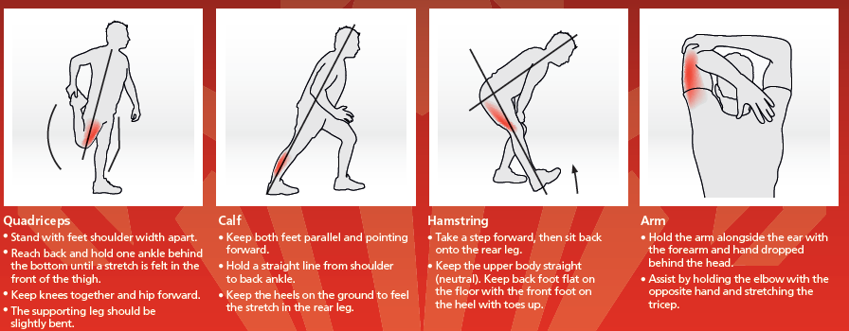
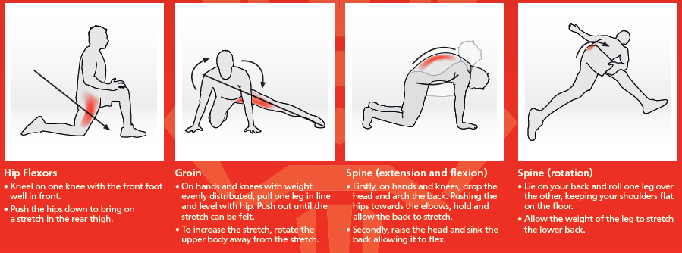
Task- Write a short paragraph to explain why stretching is important
L & L Sports Track and Field Athletics
Athlete Training Activity
Can you design your own exercise/game for a British Long Jumper?
Long jumpers need great speed in order to gain momentum for their jump. They also need to be explosive and powerful to help the jump a long distance.
Your game/ exercise must help the athlete improve on these components of fitness to help them become better jumpers.
Your athlete is:
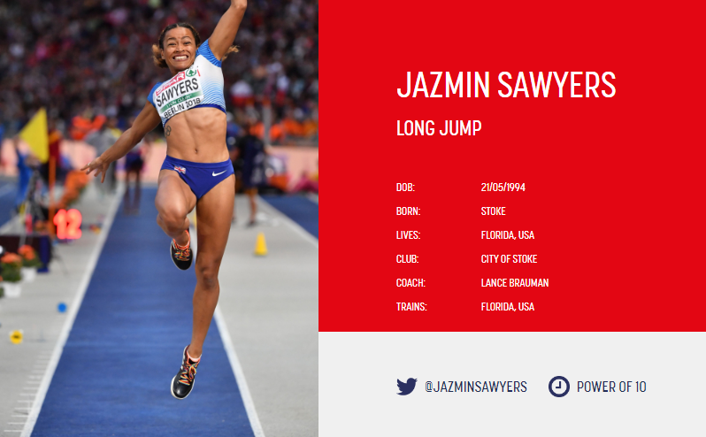

L & L Sports Track and Field Athletics
Athlete Training Activity
Game/Exercise Name: ________________________

Description: How is the game/exercise carried out?
________________________________________________________________________________________________________________________________________________________________________________________________________________________________________________________________________
Pictures / Diagrams to help Jazmin:

L & L Sports Track and Field Athletics
The Human Body

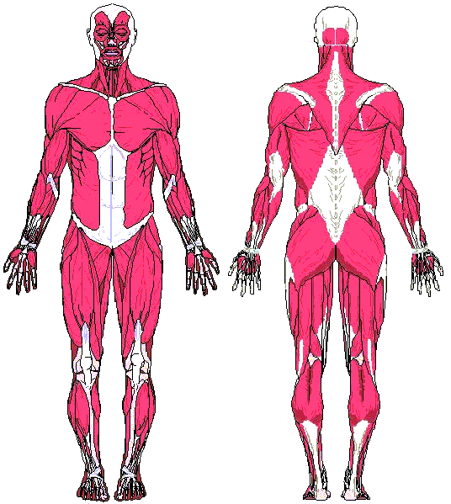
Abdominals Triceps
Biceps Calf
Quadriceps Pectoralis
Neck Muscle Hamstrings

L & L Sports Track and Field Athletics
Athletics word search

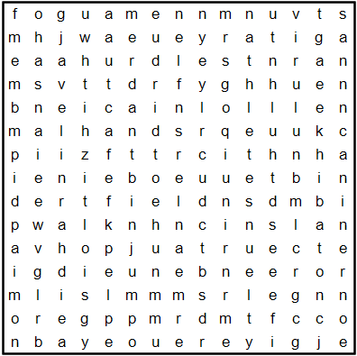

Athlete Baton Discus

Field Hop Hurdles

Javelin Jump Runner

Walk

L & L Sports Track and Field Athletics
Track & Field Drills
Running Drills
Game 1: Running Relays
Players: 1 or 2 players
First of all, you need to find some cones or markers. If you don’t have any cones, use another object as a marker. Start in the middle and run around the cone/marker at each end to complete one lap. You can start to add more laps.
- x 1 lap relay
- x 3 lap relay
- x 3 lap relay
- x 4 lap relay
What do you need to think about if you’re adding more laps?
Start Pass baton to finish

Progression: You could add in some objects to jump over to make this task more challenging!

L & L Sports Track and Field Athletics
Track & Field Drills
Throwing Drills
Game 2: Throwing
Chest push
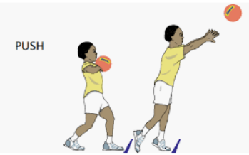
Stand behind the start line ready to perform a chest push as far as possible. You must perform the throw starting with the ball at the chest. Also you must ensure both feet are behind the throwing line. Distance is measured from where the ball bounces first.

Try a seated chest push to make this task more challenging!
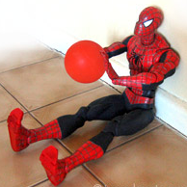

L & L Sports Track and Field Athletics
Track & Field Drills
Jumping Drills
Game 3: Standing long jump
Stand on two feet and on instruction of the recorder perform a standing jump.
The recorder then measures the distance between the take off line and the back of the heel. You need to jump as far as you can. Swing arms forward to avoid falling backwards and putting hands on the floor as this will decrease the distance jumped. Work with a partner and use spots or markers to keep a record of how far you have jumped. This will enable you to try and beat your previous measurement.
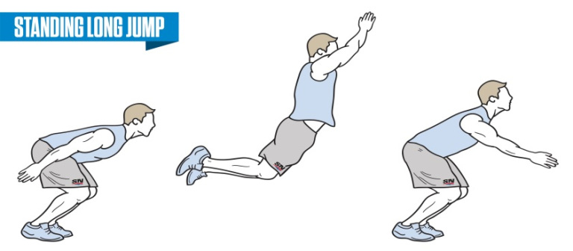
Game 4: Speed Bounce
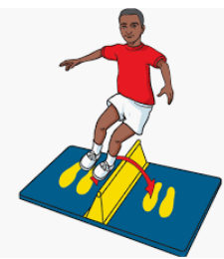
How man jumps over the barrier can you make in 30 seconds?

L & L Sports Track and Field Athletics
Athlete Fact File

Task- Create a fact file full of information about a British Athlete
Information you may want to include. These could even be spread out into different sub-headings:
-Name/Date of Birth
-Where they are from?
-What event/s do they compete in?
-Where do they train?
-Who coaches them and helps them improve?
-How did they first get into athletics?
-What do they eat?
Here is a useful website to help with your research:
https://www.britishathletics.org.uk/athletes/

_________________________
_________________________
_________________________
_________________________
_________________________
_________________________
_________________________
_________________________
________________________

________________________
________________________
________________________
________________________
________________________

________________________________________________________________________________________________________________________________________________________________________________________________________

Olympics Quiz Answers
1. 5
2. Greece
3. Bronze
4.50 Meters
5. Every 4 years
6. United States of America (USA)
7. London
8. Tokyo in Japan
9. Archery
10. Steve Redgrave

