Live and Learn Sports
FS2 Activity Pack

Striking and Fielding Skills

All activities will focus on a variety of striking and fielding skills.

Striking and Fielding Skills Quiz

Get a parent to help you and see how many questions you can answer!

Q. Does a bean bag bounce?
A. _______________________________________________________
Q. How do we throw high?
A. _______________________________________________________
Q. What should you make to catch a ball?
A. _______________________________________________________
Q. How do you throw over arm?
A. _______________________________________________________
Q. If someone isn’t looking when you want to throw, what can you do?
A. _______________________________________________________
Q. If someone is close, do we throw under or over arm?
A. _______________________________________________________
Q. How many hands do you hold a rounders bat with?
A. _______________________________________________________
Q. How many hands do you hold a tennis racket with?
A. _______________________________________________________
Q. Do you attempt to field the ball, if another player already has it?
A. _______________________________________________________
Q. Do we run left or right when we hit the ball in rounder?
A. _______________________________________________________

Marks
Ask an adult to mark your answers
/10

Self-Assessment
Did you find the questions?

Easy Ok Hard

Striking and Fielding Skills - True or False

Get a parent to help you and see how many questions you can answer True or False to!

Q. You can use two hands to strike the ball in rounders
A. _______________________________________________________
Q. You can throw over arm with two hands
A. _______________________________________________________
Q. A bean bag will not bounce
A. _______________________________________________________
Q. A ball will not bounce more than once
A. _______________________________________________________
Q. Rounders is a striking and fielding game
A. _______________________________________________________
Q. You can run in any direction after striking the ball in rounders
A. _______________________________________________________
Q. You should throw over arm if someone is close
A. _______________________________________________________
Q. You should call someone’s name to get their attention if they aren’t looking
A. _______________________________________________________
Q. You should swing the bat before the bowler bowls the ball
A. _______________________________________________________
Q. To catch someone out, the ball cannot touch the ground before hand
A. _______________________________________________________
Marks
Ask an adult to mark your answers
/10

Self-Assessment
Did you find the questions?

Easy Ok Hard

Striking Skills Wordsearch

How many of the following striking words, can you find in the wordsearch below? There are 10 to find!
Why not make it harder, and time yourself!
S | T | R | I | K | E | A | Q | W | S
Q | E | F | Y | K | J | D | B | A | T
W | A | T | H | G | Q | I | S | C | R
T | I | M | I | N | G | R | R | C | E
Q | N | B | L | I | Q | E | E | U | N
Z | M | A | O | W | E | C | D | R | G
X | R | S | K | S | R | T | N | A | T
Z | F | E | I | R | Y | I | U | C | H
V | V | S | U | P | O | O | O | Y | X
P | O | W | E | R | L | N | R | V | C

Direction
Swing
Bases
Strike
Power
Strength
Timing
Accuracy
Bat
Rounders
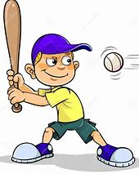

Fielding Skills Wordsearch

How many of the following fielding words, can you find in the wordsearch below? There are 10 to find!
Why not make it harder, and time yourself!

F | Q | C | A | T | C | H | Z | T | A
I | Q | P | P | E | A | A | S | A | I
E | C | O | P | A | Q | B | D | R | M
L | F | W | L | M | O | A | X | G | L
D | B | E | Y | U | I | L | Z | E | Y
I | H | R | W | Y | U | L | V | T | B
N | U | B | V | C | X | Z | S | A | Q
G | I | V | B | U | N | D | E | R | Q
W | L | E | C | Z | L | P | O | Y | R
T | H | R | O | W | M | O | V | E | R

Under
Power
Aim
Throw
Target
Catch
Over
Team
Ball
Fielding

Answer Sheet
Target Skills Quiz
- No
- Add power, release under arm throw later, or over arm throw earlier
- Make a target
- Bend elbow, place ball close to shoulder, draw semi-circle with hand pulling over and release
- Call their name
- Under arm
- One
- One
- No
- Right

Target Skills True or False
- False
- False
- True
- False
- True
- False
- False
- True
- False
- True

Target Skills 1 Wordsearch
S | T | R | I | K | E | A | Q | W | S
Q | E | F | Y | K | J | D | B | A | T
W | A | T | H | G | Q | I | S | C | R
T | I | M | I | N | G | R | R | C | E
Q | N | B | L | I | Q | E | E | U | N
Z | M | A | O | W | E | C | D | R | G
X | R | S | K | S | R | T | N | A | T
Z | F | E | I | R | Y | I | U | C | H
V | V | S | U | P | O | O | O | Y | X
P | O | W | E | R | L | N | R | V | C

Target Skills 2 Wordsearch
F | Q | C | A | T | C | H | Z | T | A
I | Q | P | P | E | A | A | S | A | I
E | C | O | P | A | Q | B | D | R | M
L | F | W | L | M | O | A | X | G | L
D | B | E | Y | U | I | L | Z | E | Y
I | H | R | W | Y | U | L | V | T | B
N | U | B | V | C | X | Z | S | A | Q
G | I | V | B | U | N | D | E | R | Q
W | L | E | C | Z | L | P | O | Y | R
T | H | R | O | W | M | O | V | E | R

Human Body Wordsearch
S | H | O | U | L | D | E | R | P | O | U | A | Q | X | N
Q | T | P | L | E | U | I | O | O | K | J | R | Q | A | E
W | G | F | O | G | L | E | A | R | S | A | M | V | Z | C
F | F | E | I | M | E | Y | E | S | C | W | Z | B | M | K
H | D | E | U | W | E | R | Q | A | X | B | V | U | O | A
A | V | T | R | S | P | I | N | E | Z | O | B | J | U | Z
N | C | A | S | E | D | F | V | R | T | D | P | Y | T | Q
D | X | E | N | O | S | E | Q | W | E | Y | L | O | H | V
Q | A | H | N | J | O | P | F | I | N | G | E | R | S | R
H | E | A | D | L | M | H | N | B | T | R | T | O | E | S

Skeleton labels
- Head
- Arm
- Body
- Hand
- Leg
- Foot

Creative/Design Ideas

Why not choose a task from the following list below and see how creative you can be?
Once you have completed one, tick it off and choose another tomorrow!

Create a game that can be played inside or on the floor

Draw and decorate a new ball
Create a dance routine or a gymnastic routine
Draw a sports player of your choice
Design your own PE kit

Design and create an obstacle course, using objects from home

Create a game which doesn’t involve equipment
Draw and label a tennis racket
Create a bat and ball game
Design your own rounders bat
Design your own trainer
Design your own throwing game

Label the Skeleton
How many body parts can you name in the human body?
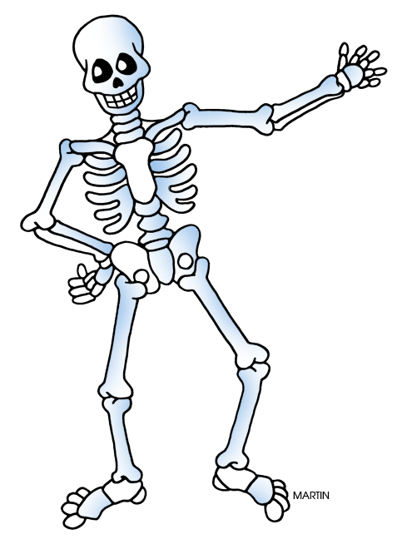

Head Leg Arm Foot Body Hand
Fitness Bingo
Below is a selection of fitness exercises which should challenge you to be more
active at home. (Cut out balls and use as markers). You can either:
Complete two exercises as a quick wake up/warm up before starting your PE session
OR
Complete the bingo card in one session as a fitness circuit in place of a PE session

30 seconds of Star Jumps

Run on the spot for 1 minute

30 seconds of Squats

Throw and catch a ball for 30 seconds

1 minute of Sit Ups

Sprint on the spot for 30 seconds

1 minute of throwing a bean bag to a partner

1 minutes of Step Ons (On a step)

Bounce a ball continuously for 30 seconds

1 minute of Star Jumps

30 seconds of Side to side Jumps

1 minute of High Knees

1 minute of Lunges

Run 5 laps around the Garden

Hold a balance for 1 minute

30 seconds standing on 1 leg

Run around the garden for 2 minutes

Hold a balance for 30 seconds

How long can you hold your arms out straight?

Squat and hold position for 30 seconds

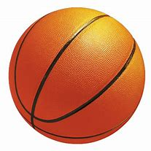
Human Body Wordsearch

How many of the following body parts, can you find in the wordsearch below? There are 15 to find!
Why not make it harder, and time yourself!
S | H | O | U | L | D | E | R | P | O | U | A | Q | X | N
Q | T | P | L | E | U | I | O | O | K | J | R | Q | A | E
W | G | F | O | G | L | E | A | R | S | A | M | V | Z | C
F | F | E | I | M | E | Y | E | S | C | W | Z | B | M | K
H | D | E | U | W | E | R | Q | A | X | B | V | U | O | A
A | V | T | R | S | P | I | N | E | Z | O | B | J | U | Z
N | C | A | S | E | D | F | V | R | T | D | P | Y | T | Q
D | X | E | N | O | S | E | Q | W | E | Y | L | O | H | V
Q | A | H | N | J | O | P | F | I | N | G | E | R | S | R
H | E | A | D | L | M | H | N | B | T | R | T | O | E | S

Shoulder
Neck
Body
Feet
Arm
Leg
Toes

Spine
Hand
Fingers
Nose
Head
Ears
Mouth
Eyes

Human Body - Organs
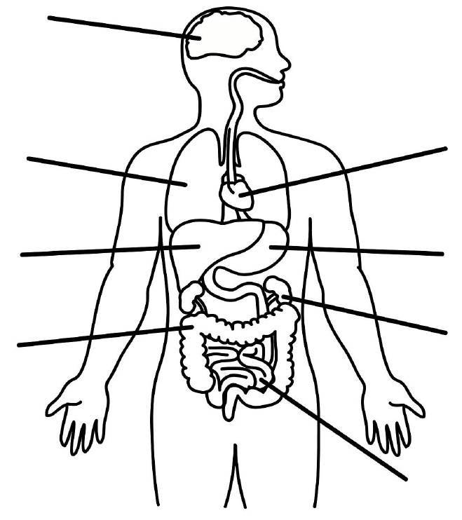
B_______

H_______
L_______

S_______
L_______

L_______
I____________
K_______

S_______
I____________

Can you label my organs correctly?
Large intestines, Kidneys, Liver, Brain, Lungs, Heart, Small intestines, Stomach
Can you colour in all the different organs?

Balanced Diet/Healthy Lifestyle
What is a balanced diet?
Can you use the plate below, to draw different foods into the correct place?
There is a selection of food on the next page which might help.
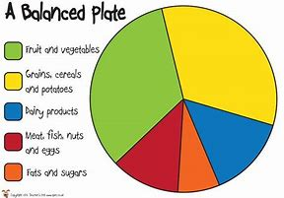

Fruit, Vegetables and Salad, Carbohydrates – Rice, Pasta, Bread, Crackers, Protein – Meat, Fish, Eggs, Fats – Cheese, Sweets, Dairy – Milk, Yoghurt.
You can use the food on the next page to give you examples of different food, that could be placed on you plate.

Pack your own Lunch Box
Your job is to pack your own lunch box for today.
Can you cut out the food below and choose a healthy balanced lunch?

Will you make a healthy decision? Why not ask an adult to check after?
Target Games
The following activities are based around Fielding games.
All sessions should last around 30 minutes, so we are aiming for one a day.
Session 6 – Reactions. Before moving on to your striking skills, you will finish will a session that will focus on your reactions. This will be good practice when you are fielding because as a fielding team you need to be fast and accurate in order to be successful against the batting team. Begin by placing two targets at the side of your marker. A partner will now throw you a ball which you must attempt to catch. As soon as you catch the ball, the bowler will call left or right (or a chosen colour to make the game easier). Your job will be to react quickly and throw the ball towards the chosen target. If you choose correctly you score 5 points. Keep playing!
Session 5 – Indoor bowling. For this game you will need to collect empty bottles from around the house. Ideally about 10, but however many you can get will work. These will work as your skittles for this game. Ask an adult or an older member of the family to help, you will need to fill the bottles about halfway up for stability and to make the game harder. Once done, position the skittles at the opposite side of the playing area. Mark out different distances from the skittles. You will begin at the closest one, using a bean bag/ball/teddy, you must throw to the skittles to knock them over. Move back and try again.
Session 4 – This session will be like session three but will work in the opposite way. Your partner will now act as the batter, and you will act as a bowler and a fielder. You will start with the ball at the bowling position and bowl the ball to your partner. They will catch the ball and wait 5 seconds for you to move back into a fielding position. As soon as you are ready, they will throw the ball anywhere within the playing area. You job is to either catch the ball, or field the ball as quickly as you can and take it back to the bowling area. To make the game harder, get the batter to count how long it takes to field the ball.
Session 2 – Around the area you are working, set up different targets. Some at closer distances and some further away. The targets can even be at different heights, maybe on a table or a chair. For this game you will need a bean bag, if this is something you have you could use a soft toy. You will now choose which is the correct throw for each target. Your job is to land the bean/bag or toy on or as close to as many targets as possible. If you throw and land in the target on turn one, you score a point, if it takes more than one turn you don’t score. How many points can you score from all the targets?
Session 3 – For this game you will need a partner. This could be a family member or a sibling. Set up a variety of targets again, just like in session two. The targets should be spread out and vary in difficulty. Your partner will start as a bowler, their job will be to bowl (throw) you the ball for you to catch. You will be facing the targets and your partner will be facing you. (Like a rounder set up). As soon as your partner throws the ball you must attempt to catch. If you do catch, you are then allowed to throw the ball and aim for a target. If you hit a target you get 10 points, If you do not catch the ball you don’t get to throw to score. How many points can you score?
Session 1 – If a partner is available, then use a partner as they will be able challenge you as the games continue. If no one can play, you can practice the throwing techniques against a wall, as the ball will bounce back for you to attempt to catch. For the first couple of minutes, practice throwing and catching a tennis ball with yourself. Can you throw with one hand and catch with the other? Or throw the ball higher. Now begin with an under-arm throw, working from player to player. If the game is too easy, move further apart, if the ball is dropped, start from the beginning. Now do the same with an over arm throw.

Target Games
The following activities are based around Striking games.
All sessions should last around 30 minutes, so we are aiming for one a day.
Session 6 – This session will work like a rounders game. If possible, ask an adult to set up some bases for you to run around, then a bowling spot and a batting spot. Your partner or family member will start as the bowler. They will bowl the ball over to you, your job will be to strike the ball as it approaches, into a space within the fielding area. As soon as the ball has been hit, you must start to run around the bases, working to your right first. Your job is to get all the way around the bases and back to battling spot, before the bowler retrieves the ball. If you get back first you score a point. Switch roles.
Session 5 – For this session you will need to set up the skittle game from the fielding sessions. Use either a variety of objects which you can knock down, or the water bottles half filled. Place the objects together to act as a group of skittles. Standing a couple of metres away. You will self-serve the ball or bean bag and strike the object towards the skittles. You are aiming to strike down as many skittles as possible. How many shots does it take to clear all the skittles? Set the skittles up again, but this time take a step back and try again. Could you now get your partner to bowl the ball/bean bag for you to strike?
Session 4 – Four corners. You will now begin to understand that as soon as you strike the ball you must run. If possible, use a family member to help with the bowling and fielding. You can always change roles, allowing you to have more practice at fielding skills too. Set up a bowling spot, a batting spot and then a scoring spot a couple of metres to the right of the batting spot. The bowler must bowl an under-arm throw towards you (the batting player). As the batter you must now attempt to strike the ball anywhere on the playing area. As soon as you strike the ball, you must run to the scoring spot. The bowler will field the ball ready to play agin.
Session 2 – This session will not only work on your timing but on your accuracy as well. The most important thing within rounders or any striking and fielding game, is that you can hit the ball, however, if you can determine where you send the ball, that is even better. Stand a metre away from your partner. To begin with, you will self-serve the bean bag/ball and send it over to your partner. They must catch and give the object back. After a few turns swap over. Now your partner will start with the ball, they must throw the bean bag/ball towards you, your job is to strike the bean bag or ball back your partner for them to catch.
Session 3 – Ask an adult or older sibling to help. You will need to set out a variety of different targets around the playing area. The targets should be set at different distances, they could also be set at different heights to make the game harder. Working with another player, you will need a bowling spot and a batting spot. You will start as the batter. The bowler bowls and under arm ball towards you, your job is to strike the bean bag/ball towards a target. If you hit the target or land close to the target, you score 10 points. Keep practising and see how many points you can get. Now let the bowler shout a target which you must try to hit towards.
Session 1 – Using whichever type pf bat you have at home; you will now start to develop your striking skills. Using a bean bag f possible, or a teddy if not, you will strike the object out towards a target. You will start this game by working on your own. You will start with the bean bag or teddy and the bat. Standing in a sideways position, you must now strike the ball towards target one. (Ask an adult to mark out a variety of different targets on the floor, starting close and working further away. If you successfully hit target one, you must now aim for target two. How many shots did it take to hit all of your targets?

