Y5-6 Activity Pack
Live and Learn Sports

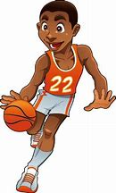

Basketball &
Netball

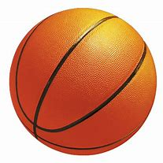
Basketball Quiz

How much do you know about Basketball? Can you answer the following questions below?

Q. How many hands should you dribble with?
A. _______________________________________________________
Q. What is a double dribble?
A. _______________________________________________________
Q. Is a double dribble allowed?
A. _______________________________________________________
Q. What is travelling?
A. _______________________________________________________
Q. What happens when you travel with the ball?
A. _______________________________________________________
Q. How does a player score?
A. _______________________________________________________
Q. What shape is a basketball court?
A. _______________________________________________________
Q. Can you name a famous basketball player?
A. _______________________________________________________
Q. What name is given to the act, where we move with the ball, continuously bouncing?
A. _______________________________________________________
Q. Where on the court does the game start?
A. _______________________________________________________

Marks
Ask an adult to mark your answers
/10

Self-Assessment
Did you find the questions?

Easy Ok Hard

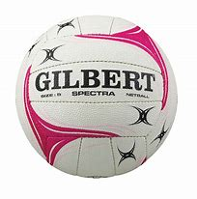
Netball Quiz

How much do you know about Netball? Can you answer the following questions below?

Q. Can you move with the ball?
A. _______________________________________________________
Q. What passes can be used in Netball?
A. _______________________________________________________
Q. How many areas is the court broken up into?
A. _______________________________________________________
Q. Can you name the playing positions on the pitch?
A. _______________________________________________________
Q. What shape is the Netball court?
A. _______________________________________________________
Q. What is the only movement a player can make, when they have the ball?
A. _______________________________________________________
Q. Where is a Centre player allowed to go?
A. _______________________________________________________
Q. What happens if someone moves with the ball?
A. _______________________________________________________
Q. Where must a player shoot from?
A. _______________________________________________________
Q. What is the rule about contact within the game?
A. _______________________________________________________
Marks
Ask an adult to mark your answers
/10

Self-Assessment
Did you find the questions?

Easy Ok Hard

Basketball Wordsearch

How many of the following basketball words, can you find in the wordsearch below? There are 15 to find!
Why not make it harder, and time yourself!

B | A | L | L | N | S | F | O | O | T | W | O | R | K | U | H | D
F | O | M | B | W | A | R | Q | M | S | Q | R | K | T | G | R | O
X | W | U | T | Q | Q | E | M | K | E | L | K | N | A | A | L | U
S | Q | L | N | A | Z | E | N | T | C | A | T | N | O | C | P | B
B | E | O | U | C | X | T | B | U | P | O | V | B | C | N | O | L
I | D | S | K | X | E | H | V | J | T | O | K | B | S | B | K | E
J | C | E | N | S | X | R | C | H | R | C | O | U | R | T | A | D
K | N | S | B | D | E | O | X | N | A | S | V | C | S | V | E | R
D | E | S | F | F | D | W | G | B | V | S | D | B | D | S | R | I
R | J | A | V | F | Y | R | A | V | E | Q | V | A | R | H | C | B
I | U | P | F | G | U | E | S | G | L | C | U | S | W | O | F | B
B | Y | Y | Q | H | Q | W | D | T | L | X | D | K | Q | O | B | L
B | C | L | S | J | K | Q | F | R | I | Z | J | E | R | T | V | E
L | V | O | L | U | O | F | G | D | N | Y | S | T | Y | Y | R | I
E | E | I | A | K | O | K | H | F | G | M | I | O | B | T | W | N
S | Q | O | P | P | O | S | I | T | I | O | N | C | N | R | R | L
Ball
Dribble
Travelling
Passes
Shoot
Free throw
Bounce
Contact
Foul
Basket
Double dribble
Footwork
Opposition
Court
Backboard

Netball Wordsearch

How many of the following basketball words, can you find in the wordsearch below? There are 15 to find!
Why not make it harder, and time yourself!

Q | W | E | U | N | S | L | K | T | H | I | R | D | S | U | H | P
P | I | V | O | T | L | K | Q | M | S | Q | R | K | T | G | F | P
X | B | R | T | Q | Q | E | M | K | E | L | K | N | A | O | L | O
S | Q | L | G | A | Z | I | V | K | N | X | X | D | U | A | P | N
A | T | T | A | C | K | K | B | A | P | O | V | L | C | L | O | E
I | D | R | K | X | P | L | V | J | R | H | C | B | S | A | K | T
J | C | R | N | N | O | N | C | O | N | T | A | C | T | T | A | E
K | N | P | B | D | E | P | E | N | P | G | V | H | S | T | E | S
R | S | I | D | E | L | I | N | E | R | N | D | E | D | A | R | L
E | J | R | V | F | Y | R | T | V | I | E | V | S | R | C | C | L
Q | U | H | H | G | U | E | R | G | Y | L | U | T | W | K | F | A
A | D | E | F | E | N | C | E | T | W | S | D | P | Q | E | B | B
Z | C | L | S | J | H | Q | F | R | W | M | J | A | R | S | V | T
S | H | O | O | T | I | N | G | D | E | R | S | S | Y | Y | R | E
Z | E | I | A | K | O | K | H | F | S | A | I | S | B | T | W | N
F | R | E | E | T | H | R | O | W | K | J | I | C | N | R | R | L
Chest pass
Travel
Foul
Thirds
Shooting D
Side line
Arms length

Pivot
Goal attack
Centre
Non contact
Free throw
Defence
Attack
Netball

Answer Sheet
Skeleton labels
- Skull
- Clavicle
- Sternum
- Humerus
- Ribs
- Spine
- Hip bone
- Ulna
- Radius
- Carpals
- Femur
- Patella
- Fibula
- Tibia
- Tarsals

Basketball Quiz
- One
- Dribbling, picking up the ball, then dribbling again
- No
- Moving with the ball and not bouncing
- The game is stopped, and a free throw is awarded to the opposition
- Shooting into the basket
- Rectangle
- Any famous player e.g. Michael Jordan
- Dribbling
- The half court line/Middle of the court

Netball Quiz
- No
- Chest, bounce, shoulder
- Thirds, with a D in both end thirds
- GK GD WD C WA GA GS (7 players)
- Rectangle
- Pivot
- Everywhere, other than the Ds
- The game is stopped, and a free throw is awarded to the opposition
- Inside the D
- None contact, must be an arm’s length from the ball

Basketball Wordsearch
B | A | L | L | N | S | F | O | O | T | W | O | R | K | U | H | D
F | O | M | B | W | A | R | Q | M | S | Q | R | K | T | G | R | O
X | W | U | T | Q | Q | E | M | K | E | L | K | N | A | A | L | U
S | Q | L | N | A | Z | E | N | T | C | A | T | N | O | C | P | B
B | E | O | U | C | X | T | B | U | P | O | V | B | C | N | O | L
I | D | S | K | X | E | H | V | J | T | O | K | B | S | B | K | E
J | C | E | N | S | X | R | C | H | R | C | O | U | R | T | A | D
K | N | S | B | D | E | O | X | N | A | S | V | C | S | V | E | R
D | E | S | F | F | D | W | G | B | V | S | D | B | D | S | R | I
R | J | A | V | F | Y | R | A | V | E | Q | V | A | R | H | C | B
I | U | P | F | G | U | E | S | G | L | C | U | S | W | O | F | B
B | Y | Y | Q | H | Q | W | D | T | L | X | D | K | Q | O | B | L
B | C | L | S | J | K | Q | F | R | I | Z | J | E | R | T | V | E
L | V | O | L | U | O | F | G | D | N | Y | S | T | Y | Y | R | I
E | E | I | A | K | O | K | H | F | G | M | I | O | B | T | W | N
S | Q | O | P | P | O | S | I | T | I | O | N | C | N | R | R | L

Netball Wordsearch
Q | W | E | U | N | S | L | K | T | H | I | R | D | S | U | H | P
P | I | V | O | T | L | K | Q | M | S | Q | R | K | T | G | F | P
X | B | R | T | Q | Q | E | M | K | E | L | K | N | A | O | L | O
S | Q | L | G | A | Z | I | V | K | N | X | X | D | U | A | P | N
A | T | T | A | C | K | K | B | A | P | O | V | L | C | L | O | E
I | D | R | K | X | P | L | V | J | R | H | C | B | S | A | K | T
J | C | R | N | N | O | N | C | O | N | T | A | C | T | T | A | E
K | N | P | B | D | E | P | E | N | P | G | V | H | S | T | E | S
R | S | I | D | E | L | I | N | E | R | N | D | E | D | A | R | L
E | J | R | V | F | Y | R | T | V | I | E | V | S | R | C | C | L
Q | U | H | H | G | U | E | R | G | Y | L | U | T | W | K | F | A
A | D | E | F | E | N | C | E | T | W | S | D | P | Q | E | B | B
Z | C | L | S | J | H | Q | F | R | W | M | J | A | R | S | V | T
S | H | O | O | T | I | N | G | D | E | R | S | S | Y | Y | R | E
Z | E | I | A | K | O | K | H | F | S | A | I | S | B | T | W | N
F | R | E | E | T | H | R | O | W | K | J | I | C | N | R | R | L

Human Body Wordsearch
T | B | N | M | N | S | S | T | E | R | N | U | M | Y | U | H | F
F | I | M | B | W | A | D | Q | M | S | Q | R | K | T | G | E | H
X | X | B | T | Q | Q | F | M | K | E | L | K | N | A | M | L | N
S | Q | L | I | A | Z | P | N | S | U | R | E | M | U | H | P | M
B | E | O | U | A | X | O | B | U | P | O | V | R | C | N | O | K
I | D | U | K | X | C | I | V | J | F | O | B | B | S | B | K | S
J | C | L | N | S | S | U | C | H | A | L | U | P | A | C | S | E
K | N | N | B | D | U | Y | X | N | D | S | V | C | S | V | E | N
L | M | A | N | D | I | B | L | E | P | S | D | E | D | A | R | O
M | J | Q | V | F | D | R | A | V | A | Q | V | L | R | I | C | B
A | U | W | F | G | A | E | S | G | T | C | U | C | W | B | F | L
L | Y | Y | Q | H | R | W | D | T | E | X | D | I | Q | I | B | A
U | C | L | S | J | K | Q | F | R | L | Z | J | V | R | T | V | P
B | V | O | F | E | M | U | R | D | L | Y | S | A | Y | Y | R | R
I | E | I | A | K | O | K | H | F | A | M | I | L | B | T | W | A
F | Q | P | H | A | L | A | N | G | E | S | L | C | N | R | R | C

Creative/Design Ideas

Why not choose a task from the following list below and see how creative you can be?
Once you have completed one, tick it off and choose another tomorrow!

Create a game that can be played inside or on the floor

Design and create a new ball
Create a dance routine or a gymnastic routine
Create a basketball stadium using a box
Design your own PE kit

Design and create an obstacle course, using objects from home

Create a game which doesn’t involve equipment
Draw and label a Netball court
Create a new ball game
Draw and label a basketball court
Design your own trainer
Design your own basketball or netball outfit

Label the Skeleton
How many bones can you name in the human body?
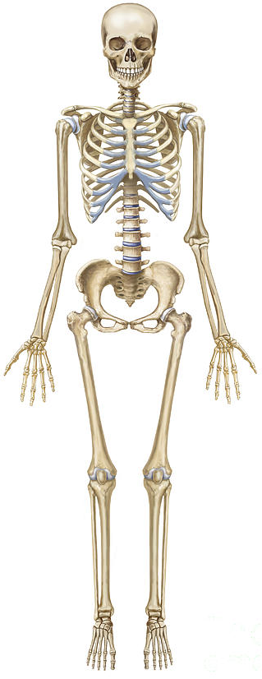
1

2

3
4
5
6
7
8
9
10

11

12

13
14

15

Ribs
Femur
Clavicle/Shoulder
Patella
Tibia
Sternum
Carpals
Humerus
Radius
Spine

Skull
Hip bone
Tarsals
Ulna
Fibula

Fitness Bingo
Below is a selection of fitness exercises which should challenge you to be more
active at home. (Cut out balls and use as markers). You can either:
Complete two exercises as a quick wake up/warm up before starting your PE session
OR
Complete the bingo card in one session as a fitness circuit in place of a PE session

30 seconds of Star Jumps

Run on the spot for 1 minute

30 seconds of Squats

Pass a ball around your waist for 30 seconds

1 minute of Sit Ups

Sprint on the spot for 30 seconds

1 minute of Press Ups

1 minutes of Step Ons (On a step)

Bounce a ball continuous for 1 minute

1 minute of Burpees

30 seconds of Jumping Lunges

1 minute of High Knees

1 minute of Lunges

Run 5 laps around the Garden

Hold the Plank for 1 minute

30 seconds of Jumping Squats

1 minute of Tricep Dips

Hold a balance for 30 seconds

How long can you hold your arms out straight?

Squat and hold position for 30 seconds

Human Body Wordsearch

How many of the following body parts, can you find in the wordsearch below? There are 15 to find!
Why not make it harder, and time yourself!
T | B | N | M | N | S | S | T | E | R | N | U | M | Y | U | H | F
F | I | M | B | W | A | D | Q | M | S | Q | R | K | T | G | E | H
X | X | B | T | Q | Q | F | M | K | E | L | K | N | A | M | L | N
S | Q | L | I | A | Z | P | N | S | U | R | E | M | U | H | P | M
B | E | O | U | A | X | O | B | U | P | O | V | R | C | N | O | K
I | D | U | K | X | C | I | V | J | F | O | B | B | S | B | K | S
J | C | L | N | S | S | U | C | H | A | L | U | P | A | C | S | E
K | N | N | B | D | U | Y | X | N | D | S | V | C | S | V | E | N
L | M | A | N | D | I | B | L | E | P | S | D | E | D | R | R | O
M | J | Q | V | F | D | R | A | V | A | Q | V | L | R | A | C | B
A | U | W | F | G | A | E | S | G | T | C | U | C | W | B | F | L
L | Y | Y | Q | H | R | W | D | T | E | X | D | I | Q | M | B | A
U | C | L | S | J | K | Q | F | R | L | Z | J | V | R | U | V | P
B | C | R | A | N | I | U | M | D | L | Y | S | A | Y | L | R | R
I | E | I | A | K | O | K | H | F | A | M | I | L | B | T | W | A
F | Q | P | H | A | L | A | N | G | E | S | L | C | N | R | R | C

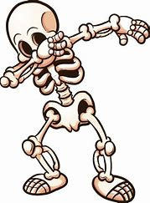
Clavicle
Humerus
Lumbar
Sternum
Ulna
Radius
Cranium

Fibula
Phalanges
Femur
Patella
Tibia
Carpal bones
Scapula
Mandible

Human Body - Organs
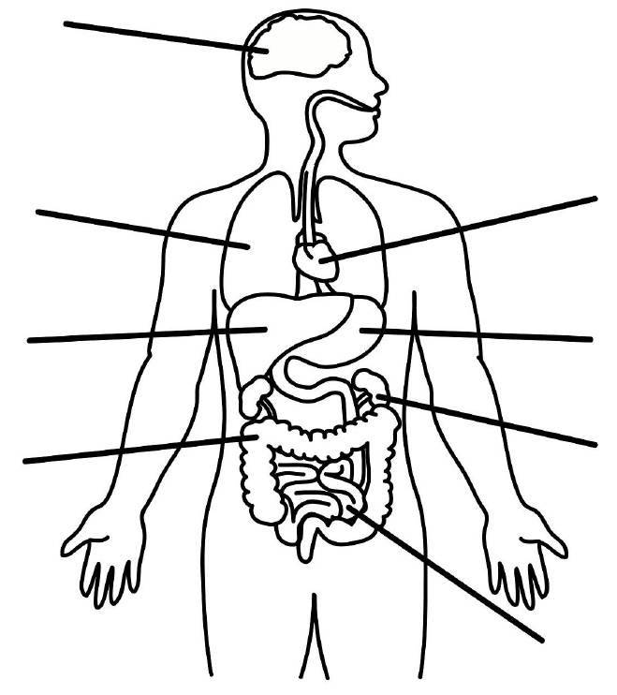

Do you know what any of our organs are called? If so, can you label the organs on the diagram.
Do you know any functions/jobs of our organs?
If so, list them.
Balanced Diet/Healthy Lifestyle
What is a balanced diet?
Can you use the plate below, to write/draw different foods into the correct place? Thinking about which foods fit into those categories.
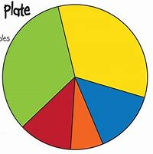

Fruit and Vegetables, Carbohydrates, Protein, Fats and Dairy.

What is a healthy lifestyle?
Can you create a poster to inform others about why a healthy lifestyle is so important? Points to include:
Hygiene
Drinking water
Positive effects of exercising
Exercising – Why is this important?
Balanced diet
Communication with others
Body weight
Getting enough sleep
Basketball Sessions
The following activities are based around Basketball.
All sessions should last around 30 minutes, so we are aiming for one a day.
Session 6 – This last session can be used to recap any of the above games/skills. If you have a family member who can join in, you can develop all the above skills into a game situation. Playing a 1v1 game, shooting against the hoop/marker on the wall. If no goals are available, then you can gain points for possession, if you keep the ball for 20 seconds you score a point. Why not try a challenge now? How many right-handed bounces can you perform in one minute? How many left-handed bounces? How many times can you pass the ball around your body in one minute? How many passes with a partner, can you make in one minute?
Session 5 – This session will focus on your shooting skills. If you have a basketball hoop at home then use that, if you don’t you could mark out with chalk/tape an area on the wall to shoot out. (Ask an adult). Start by marking out areas to shoot from, least must start close and get further away as the game goes on. Start at the closest marker, if you make the shot and score, you gain one point for you, however if you miss, the opposition (pretend player) gets a point. You get 10 shots at each marker. After marker one, move back to marker two. Continue to move back after every 10 shots. You can also choose different angles to make the game harder.
Session 4 – This session will focus on some Attacking and Defending skills. This session will be easier with a partner, however if that is not possible, then objects such as chairs can act as barriers. Mark out a playing area. You must not go out of this area, if you do, you lose on that turn. Your task is to get from one end of the area to the other without losing control, or letting the defender stop you. If the defender stops you, or manages to make a steal, then they score a point. You can then swap over with your partner, player two must now attempt to reach the opposite side of the area without losing control. If using chairs, work around them instead.
Session 2 – This session you will focus on your passing skills. If possible, use a partner. (Sibling/Parent) 1. Stand a few metres apart, player one dribbles out around partner and back, when back perform a chest pass to partner, partner copies. 2. Now play the same game, but this time play a bounce pass. (Ensure the ball only bounces once). 3. Now play the same game, but the pass must this time be a shoulder pass. 4. How fast can you perform 20 chest passes (without dropping)? 5. How fast can you perform 20 bounce passes? 6. How fast can you perform 20 shoulder passes? If no partner, play the passes towards a ball.
Session 3 – This session is going to give you time to recap on the basic skills of dribbling and passing. Again, if you can work with a partner or as an adult to help that would be perfect. You will use an area of your choice to work. On your partners command, you must complete the following skills: 1. Dribble 2. Pass the ball around your waist 3. Take the ball through your legs, in a figure of eight 4. Throw the ball up and catch the ball 5. Perform a pass towards the wall (outside) and receive. Extension – If you are working with a sibling, they can now get involved, by adding in the passes but to your partner.
Session 1 – This session will focus on basic ball skills. Create a working area. Across the garden/patio. 1. Work from one end to the other, dribbling the ball whilst moving. 2. This time dribble to the opposite end, when there, stop and take the ball around your body 3 times. 3. Dribble to the opposite end, stop and draw a figure of 8 around your legs, dribble back. 4. Now create an obstacle on the floor to dribble around. As you work to the opposite end, make sure you are changing direction and working side to side instead of straight forward.
5. Perform a combination of the above games to finish.

Netball Sessions
The following activities are based around Netball.
All sessions should last around 30 minutes, so we are aiming for one a day.
Session 6 – This last session will focus on your attacking and defending skills. If you have more than one person at home, then you can add a defender into your game to make it harder. You can play a 2v1 game, where you and your partner cannot move with the ball but will work together to get the ball towards the shooting zone to score. The defender will attempt to stop you. If you do not have more than two people at home, then player one will be the attacking player and aim to shoot towards a spot on the wall to score. The defending player will stand inbetween player one and the wall and act as a barrier. Swap over with your partner.
Session 5 – For this session we will focus on your accuracy of passing. You and a partner must stand a few metres apart. At the side of each player, place two spots about a metre away each. Your partner will start with the ball and pass the ball to you to receive. As soon as you receive the ball, your partner will call left or right. At that point you must pivot to the correct side and bounce the ball on that side. If you hit the spot you score a point, if you miss you don’t. Now return to your partner for them to work on their reactions. Now place different buckets or targets around the garden. This time receive the ball and shoot to a target.
Session 4 – This session will focus on shooting skills. In Netball the basket has no backboard, so there is nothing to rebound off, however at home if there is no net/hoop, then mark an area on the wall or use a bucket placed high, which the ball must loop into. This game is Shooting Shuttles. Set up four different markers away from the basket/bucket and give each marker a value. The closest will have the least amount of points and the furthest will score you the most. If possible, get a player to stand at the side and feed the ball in. You must run to a line of your choice, receive the ball and stop. Then shoot towards the basket. How many points can you score?
Session 2 – This second session will focus on your passing skills, as well as how fast/accurate you can receive the ball. If a partner is available then use them, if not, then the ball can be passed against the wall for it to rebound. If a family member is helping, they will use numbers to give you commands: 1. Stop 2. Bounce and catch the ball 3. Stop and pivot 4. Perform a chest pass 5. Perform a bounce pass 6. Perform a shoulder pass. Your job will be to move around the area then react to one of the commands. Extension – Your partner will now start with the ball, then will throw the ball in at any time for you to catch, as soon as you catch you must stop!
Session 3 – For this session, we are going to play a game called island. You will need a partner/family member to help. Mark out on the floor different islands and number/name them. You family member will start by standing in the centre of your area/garden. Their job will be to call out a name or number for you to run to. You will make your way to that island as fast as possible; they will then throw the ball to you for you to catch/receive. Once you have caught the ball, they will tell you which pass to play back to them. Now make your way to the next island. Can you time yourself working to 10 islands and try to then beat the score?
Session 1 – The next few workout/PE sessions will work on the basic Netball Skills and Rules. If a family member is available to help, get them involved. This first session is all about your control and passing techniques. 1. If you have a partner, stand a few metres apart, and get them to start with the ball. You must run around your partner, then as you get back to your spot, they will perform a chest pass to you. Take turns. 2. Now play the same game, but this time, make a bounce pass to each other as you return. 3. Again, same game but now focusing on a shoulder pass. 4. How many of each pass can you make in 1 minute?

