Target Skills
Live and Learn Sports
Y1-2 Activity Pack

All activities will focus on a variety of target skills and games

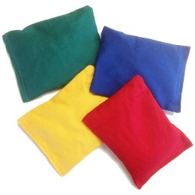
Target Skills Quiz

How much do you know about Basketball? Can you answer the following questions below?

Q. How do we throw under arm?
A. _______________________________________________________
Q. How do you change your speed?
A. _______________________________________________________
Q. How many hands do you throw a Javelin with?
A. _______________________________________________________
Q. Where does a chest push start from?
A. _______________________________________________________
Q. How many hands do we throw a discus with?
A. _______________________________________________________
Q. How do we aim high?
A. _______________________________________________________
Q. How do we perform a shoulder pass?
A. _______________________________________________________
Q. What is bigger, a Football or a Tennis ball?
A. _______________________________________________________
Q. How many bounces should be in a bounce pass?
A. _______________________________________________________
Q. Do we roll or throw a Boccia ball?
A. _______________________________________________________

Marks
Ask an adult to mark your answers
/10

Self-Assessment
Did you find the questions?

Easy Ok Hard

Target Skills True or False

How much do you know about Target Skills? Are the following questions by choosing true or false?

Q. You can throw the Javelin with two hands
A. _______________________________________________________
Q. You must start a chest pass from your chest
A. _______________________________________________________
Q. A Tennis ball will bounce
A. _______________________________________________________
Q. If I want to throw further, I must throw softer
A. _______________________________________________________
Q. Golf is a target aiming game
A. _______________________________________________________
Q. You can throw and bounce a Boccia ball
A. _______________________________________________________
Q. Someone else can change my power
A. _______________________________________________________
Q. You can throw a ball soft and hard
A. _______________________________________________________
Q. A bean bag will bounce
A. _______________________________________________________
Q. If you drop a Football it will bounce
A. _______________________________________________________
Marks
Ask an adult to mark your answers
/10

Self-Assessment
Did you find the questions?

Easy Ok Hard

Target Skills 1 Wordsearch

How many of the following target words, can you find in the wordsearch below? There are 10 to find!
Why not make it harder, and time yourself!

T | H | R | O | W | S | E | W | T | H | G | I | E | H | U | H | E
F | A | M | B | W | A | W | Q | M | S | Q | R | K | T | G | U | C
X | W | D | T | Q | Q | E | M | K | E | L | K | N | A | Y | T | N
S | Q | L | R | A | Z | Q | N | P | O | W | E | R | U | B | B | A
B | E | O | U | M | X | T | B | U | P | O | V | B | P | N | O | T
I | D | J | K | X | W | E | I | G | H | T | K | A | S | B | K | S
J | C | U | N | S | X | R | C | H | F | C | C | A | O | B | A | I
K | N | D | B | D | E | W | X | N | F | S | V | C | S | V | E | D
G | E | G | F | F | D | S | G | B | Y | S | D | S | D | S | R | M
F | J | E | V | F | Y | R | A | E | C | N | U | O | B | I | C | N
R | U | R | F | G | T | E | S | G | A | C | U | W | W | Z | F | B
J | Y | Y | Q | E | Q | W | D | T | R | X | D | Q | Q | E | B | V
U | C | L | G | J | K | Q | F | R | U | Z | J | Y | R | D | V | D
W | V | R | I | M | U | F | G | D | C | Y | S | I | Y | Y | R | I
Q | A | I | A | K | O | K | H | F | C | M | I | O | B | T | W | N
T | Q | O | P | M | U | G | T | T | A | C | V | C | N | R | R | L
Target
Throw
Distance
Power
Bounce
Accuracy
Height
Weight
Judge
Size
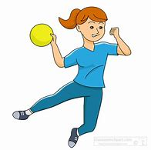

Target Skills 2 Wordsearch

How many of the following target words, can you find in the wordsearch below? There are 10 to find!
Why not make it harder, and time yourself!

Q | W | E | U | N | S | L | K | Q | W | E | C | B | S | U | H | D
C | G | G | S | U | L | K | Q | M | S | Q | R | K | T | G | I | P
O | B | R | P | Q | Q | E | M | K | E | B | K | N | A | S | L | O
N | Q | L | E | A | Z | I | V | K | N | A | X | D | C | A | P | N
T | E | Y | E | Y | U | K | B | A | P | L | V | U | C | L | O | E
R | D | R | D | X | P | L | V | J | R | L | S | B | S | A | K | T
O | C | R | N | N | O | N | O | P | U | T | N | M | T | T | A | E
L | N | P | B | D | E | P | E | N | P | G | V | H | S | T | E | S
R | B | E | A | N | B | A | G | R | R | N | D | E | D | A | R | A
E | J | R | V | F | Y | R | O | B | J | E | C | T | R | C | C | I
Q | U | H | H | G | U | E | R | G | Y | L | U | O | W | K | F | M
A | W | Y | G | B | Z | Z | E | T | W | S | D | O | Q | E | B | Z
Z | C | L | S | J | H | Q | L | R | W | M | J | H | R | S | V | T
W | A | X | Z | C | I | N | G | D | E | R | S | S | Y | Y | R | E
Z | E | I | A | K | O | K | N | F | S | A | I | S | B | T | W | N
W | Q | N | I | L | E | V | A | J | K | J | I | C | N | R | R | L
Shoot
Aim
Angle
Speed
Control
Ball
Object
Javelin
Discus
Bean bag

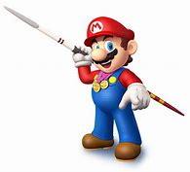

Answer Sheet
Target Skills Quiz
- Start with hand by side, swing back and release as arm comes forward
- Throw harder or softer
- 1
- Chest
- 1 hand holds, 1 hand can support
- Use opposite hand to point, don’t rush, look where you are throwing
- Balance ball on strongest hand, then up onto shoulder, extend and push
- Football
- 1
- Roll

Target Skills True or False
- False
- True
- True
- False
- True
- False
- False
- True
- False
- True

Target Skills 1 Wordsearch
T | H | R | O | W | S | E | W | T | H | G | I | E | H | U | H | E
F | A | M | B | W | A | W | Q | M | S | Q | R | K | T | G | U | C
X | W | D | T | Q | Q | E | M | K | E | L | K | N | A | Y | T | N
S | Q | L | R | A | Z | Q | N | P | O | W | E | R | U | B | B | A
B | E | O | U | M | X | T | B | U | P | O | V | B | P | N | O | T
I | D | J | K | X | W | E | I | G | H | T | K | A | S | B | K | S
J | C | U | N | S | X | R | C | H | F | C | C | A | O | B | A | I
K | N | D | B | D | E | W | X | N | F | S | V | C | S | V | E | D
G | E | G | F | F | D | S | G | B | Y | S | D | S | D | S | R | M
F | J | E | V | F | Y | R | A | E | C | N | U | O | B | I | C | N
R | U | R | F | G | T | E | S | G | A | C | U | W | W | Z | F | B
J | Y | Y | Q | E | Q | W | D | T | R | X | D | Q | Q | E | B | V
U | C | L | G | J | K | Q | F | R | U | Z | J | Y | R | D | V | D
W | V | R | I | M | U | F | G | D | C | Y | S | I | Y | Y | R | I
Q | A | I | A | K | O | K | H | F | C | M | I | O | B | T | W | N
T | Q | O | P | M | U | G | T | T | A | C | V | C | N | R | R | L

Target Skills 2 Wordsearch
Q | W | E | U | N | S | L | K | Q | W | E | C | B | S | U | H | D
C | G | G | S | U | L | K | Q | M | S | Q | R | K | T | G | I | P
O | B | R | P | Q | Q | E | M | K | E | B | K | N | A | S | L | O
N | Q | L | E | A | Z | I | V | K | N | A | X | D | C | A | P | N
T | E | Y | E | Y | U | K | B | A | P | L | V | U | C | L | O | E
R | D | R | D | X | P | L | V | J | R | L | S | B | S | A | K | T
O | C | R | N | N | O | N | O | P | U | T | N | M | T | T | A | E
L | N | P | B | D | E | P | E | N | P | G | V | H | S | T | E | S
R | B | E | A | N | B | A | G | R | R | N | D | E | D | A | R | A
E | J | R | V | F | Y | R | O | B | J | E | C | T | R | C | C | I
Q | U | H | H | G | U | E | R | G | Y | L | U | O | W | K | F | M
A | W | Y | G | B | Z | Z | E | T | W | S | D | O | Q | E | B | Z
Z | C | L | S | J | H | Q | L | R | W | M | J | H | R | S | V | T
W | A | X | Z | C | I | N | G | D | E | R | S | S | Y | Y | R | E
Z | E | I | A | K | O | K | N | F | S | A | I | S | B | T | W | N
W | Q | N | I | L | E | V | A | J | K | J | I | C | N | R | R | L

Human Body Wordsearch
T | B | N | M | N | S | C | H | E | S | T | U | M | Y | U | H | L
F | I | M | B | W | A | D | Q | M | S | Q | R | K | T | G | E | E
X | X | B | T | Q | Q | F | M | K | E | L | K | N | A | M | L | G
S | Q | L | I | A | Z | F | U | N | N | Y | B | O | N | E | P | M
B | E | O | U | A | X | O | B | U | P | O | V | R | C | N | O | K
I | D | U | K | X | C | I | V | J | F | O | B | B | S | B | K | S
J | C | L | N | S | Q | U | C | H | A | L | U | P | A | C | S | E
K | N | N | B | D | W | Y | X | N | D | S | V | C | S | V | E | N
L | J | A | W | B | O | N | E | Q | K | S | D | R | D | R | R | O
M | J | Q | V | O | X | R | A | V | N | Q | V | E | R | E | C | B
A | U | W | F | N | Z | E | S | H | E | C | U | D | W | N | F | T
L | Y | Y | Q | E | Q | W | D | T | E | X | D | L | Q | I | B | S
U | C | L | S | J | K | Q | F | R | L | Z | J | U | R | P | V | I
B | C | R | S | K | U | L | L | D | L | Y | S | O | Y | S | R | R
I | E | I | A | K | O | K | H | F | A | M | I | H | B | T | W | W
F | Q | F | I | N | G | E | R | S | E | S | L | S | N | R | R | M

Skeleton labels
- Skull
- Neck
- Shoulder
- Rib Cage
- Spine
- Arm
- Elbow
- Wrist
- Hand
- Fingers
- Knee
- Leg
- Ankle
- Foot
- Toes

Creative/Design Ideas

Why not choose a task from the following list below and see how creative you can be?
Once you have completed one, tick it off and choose another tomorrow!

Create a game that can be played inside or on the floor

Design and create a new ball
Create a dance routine or a gymnastic routine
Create a sports scene using a box
Design your own PE kit

Design and create an obstacle course, using objects from home

Create a game which doesn’t involve equipment
Draw and label a Javelin
Create a new ball game
Draw and label a Football pitch
Design your own trainer
Design your own target game

Label the Skeleton
How many body parts can you name in the human body?
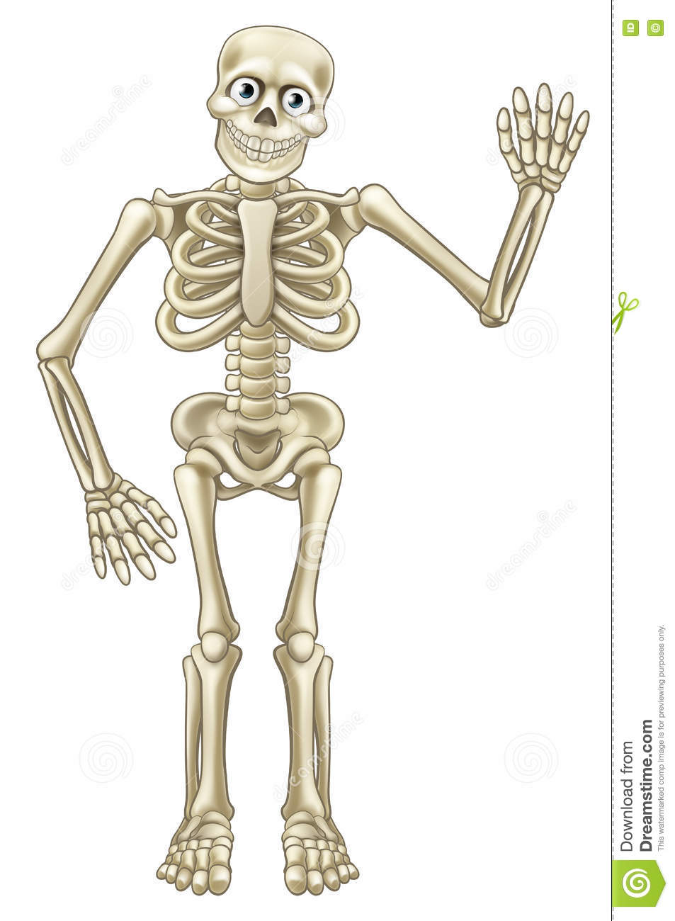
1

2
3
4

5
7
6

8
9
10

11

12

13
14
15

Toes
Leg
Shoulder
Knee
Hands
Rib Cage
Wrist
Elbow
Ankle
Arm

Skull
Neck
Feet
Spine
Fingers

Fitness Bingo
Below is a selection of fitness exercises which should challenge you to be more
active at home. (Cut out balls and use as markers). You can either:
Complete two exercises as a quick wake up/warm up before starting your PE session
OR
Complete the bingo card in one session as a fitness circuit in place of a PE session

30 seconds of Star Jumps

Run on the spot for 1 minute

30 seconds of Squats

Pass a ball around your waist for 30 seconds

1 minute of Sit Ups

Sprint on the spot for 30 seconds

1 minute of throwing a bean bag to a partner

1 minutes of Step Ons (On a step)

Bounce a ball continuously for 1 minute

1 minute of Star Jumps

30 seconds of Side to side Jumps

1 minute of High Knees

1 minute of Lunges

Run 5 laps around the Garden

Hold a balance for 1 minute

30 seconds standing on 1 leg

Run around the garden for 2 minutes

Hold a balance for 30 seconds

How long can you hold your arms out straight?

Squat and hold position for 30 seconds

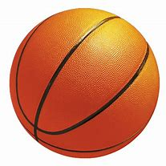
Human Body Wordsearch

How many of the following body parts, can you find in the wordsearch below? There are 15 to find!
Why not make it harder, and time yourself!
T | B | N | M | N | S | C | H | E | S | T | U | M | Y | U | H | L
F | I | M | B | W | A | D | Q | M | S | Q | R | K | T | G | E | E
X | X | B | T | Q | Q | F | M | K | E | L | K | N | A | M | L | G
S | Q | L | I | A | Z | F | U | N | N | Y | B | O | N | E | P | M
B | E | O | U | A | X | O | B | U | P | O | V | R | C | N | O | K
I | D | U | K | X | C | I | V | J | F | O | B | B | S | B | K | S
J | C | L | N | S | Q | U | C | H | A | L | U | P | A | C | S | E
K | N | N | B | D | W | Y | X | N | D | S | V | C | S | V | E | N
L | J | A | W | B | O | N | E | Q | K | S | D | R | D | R | R | O
M | J | Q | V | O | X | R | A | V | N | Q | V | E | R | E | C | B
A | U | W | F | N | Z | E | S | H | E | C | U | D | W | N | F | T
L | Y | Y | Q | E | Q | W | D | T | E | X | D | L | Q | I | B | S
U | C | L | S | J | K | Q | F | R | L | Z | J | U | R | P | V | I
B | C | R | S | K | U | L | L | D | L | Y | S | O | Y | S | R | R
I | E | I | A | K | O | K | H | F | A | M | I | H | B | T | W | W
F | Q | F | I | N | G | E | R | S | E | S | L | S | N | R | R | M

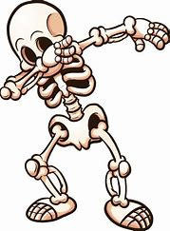
Shoulder
Funny bone
Spine
Chest
Ulna
Radius
Skull

Fibula
Fingers
Leg
Knee
Tibia
Wrist bones
Scapula
Jaw bone

Human Body - Organs
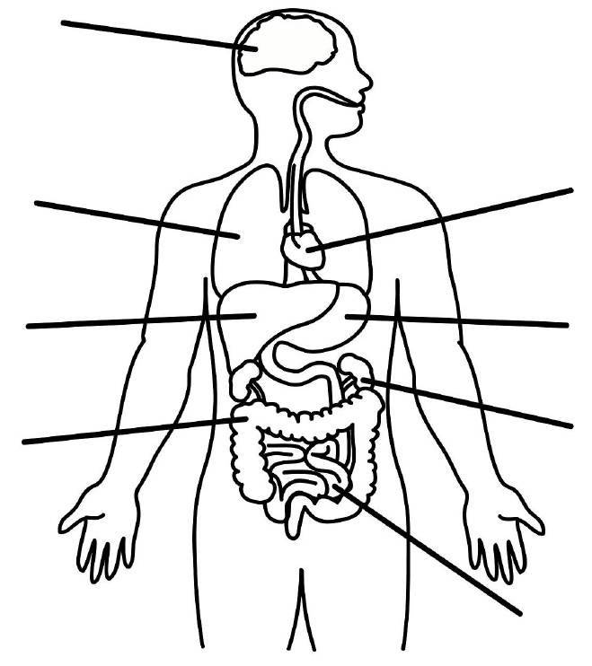

Can you label my organs correctly?
Large intestines, Kidneys, Liver, Brain, Lungs, Heart, Small intestines, Stomach
Can you colour in all my different organs?
Balanced Diet/Healthy Lifestyle
What is a balanced diet?
Can you use the plate below, to draw different foods into the correct place? Thinking about which foods fit into those categories.
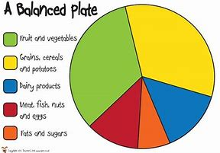

Fruit, Vegetables and Salad, Carbohydrates – Rice, Pasta, Bread, Crackers, Protein – Meat, Fish, Eggs, Fats – Cheese, Sweets, Dairy – Milk, Yoghurt.
You can use the food on the next page to give you examples of different food, that could be placed on you plate.

Pack your own Lunch Box
Your job is to pack your own lunch box for today.
Can you cut out the food below and choose a healthy balanced lunch?

Will you make a healthy decision? Why not ask an adult to check after?
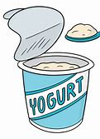
Target Games
The following activities are based around Target games.
All sessions should last around 30 minutes, so we are aiming for one a day.
Session 6 – Beat the defender. If a family member or friend can play, then you can take it in turns to be the defender, which you are attempting to beat. On an outside wall, you will need to create a few different markers. This could be a mark that is already on the wall, or you could use tape, paper or chalk to mark areas out. Before the game, decide how many points you would like each area to be. Your job now is to stand a couple of metres from the wall and throw a ball or a bean bag towards the targets. You will have 10 attempts. Make sure you are adding up your score. Whoever has the most points at the end wins.
Session 5 – Battle Ships. If a partner is available, you can play against your partner, if no one is available to play, then you can play against yourself. You could even play one arm against the other, throw right-handed on one side and left-handed on the other. You will need a dividing line in the centre of the game. One both side you will then need ‘Ships’ laid out, these can be any markers you have around the house or garden. You will then need a throwing area, which will be behind your ships and an object to throw with. (Ideally a Javelin or bean bag, but a teddy can also be used). You are aiming to hit your partners Ships to sink them and win the game.
Session 4 – Foot Golf. This session will be like the Islands game, however this time you will be playing with your feet. Ideally this time we need to be working outside. If you have a parent or older sibling who could set up for you, it will make the game more challenging. Once a course has been set up, your job will be to get the ball from the starting ‘Tee off’ zone to the first hole. You must only kick the ball, do not throw or roll. The ball must land either in the hole, or next to the hole for you to score. Once you have scored and putted hole one, you can move on to hole two. Why not see how many shots you can make it around in?
Session 2 – Islands. Set up a variety of islands/safe zones which you will work into during this session. The aim of the game is to visit every island until you reach the end of your Journey. This can be played inside or outside. If played inside, you can work from room to room, or ever upstairs. You will have a bean bag/teddy which will act as your marker. You must throw the bean bag/teddy from your starting Island, across to Island number two. If you miss the second Island, you are not allowed to continue your Journey and you must start again. If you land your marker on the next Island you are free to travel. How fast can you complete your Journey?
Session 3 – Boccia. Boccia is a target aiming game where you will aim to be the closest player to the Jacque ball. If you do not have any Boccia ball or bowls, any rolling ball will work. The Jacque ball can be replaced by any marker, for example, a bench, a hoop, a plant pot, a coaster. You can play this game will few people oe with higher numbers if you have siblings at home. Place a throwing marker a few metres away from the Jacque/target. You will now take it in turns to roll your ball and land as close to the target as possible. Whoever is the closest wins. Extension – Change marker so it is smaller, move throwing area further away.
Session 1 – Noughts and Crosses. For this game, you will need a partner, however, if a partner isn’t available you can still practice aiming for the specific squares you would like to score in. Ask an adult if you are struggling, you will need to mark out a noughts and crosses game on the floor. (Chalk, rope, string, tape) You will then need a marker a metre away for you and your partner to throw from. You will start at the opposite side of the area and run with a bean bag/toy to the throwing area, once here you must aim for the square you would like to mark in. The aim is to make a line of your markers before your partner.

Target Games
The following activities are based around Target games.
All sessions should last around 30 minutes, so we are aiming for one a day.
Session 6 – Pin Wheel. This game is the opposite to our Skittle/Bowling game. Again, use equipment from around the house/garden to act as your skittles. (Ask an adult first) Place the skittles in the centre of the playing area. Again, mark out a ladder of throwing markers. You will start from the closest marker and throw a bean bag/teddy into the target area. However, this time we are aiming to not knock the skittles down. If you successfully throw without knocking a skittle, you move back to throwing marker two. If you knock a skittle you stay at marker one. Who can reach the end of their ladder first?
Session 5 – Through the gate. Using two cones or any garden equipment you have, create a gate in the middle of the playing area. The gate can start wide, then get smaller as the game goes on to challenge you and any other players. Mark out a ladder of distances, starting close to the gate and working further away. If playing with a partner they will require the same on the opposite side. Taking a ball of your choice, you will now start from marker one, and pass the ball through the gate. If you successfully pass the ball through, you move to marker two and so on. Who will reach the end of the ladder first? Now make the gate smaller.
Session 4 – 21. This game will not only work on your target aiming skills, but your counting as well. You will need a large target which you will be aiming for. Inside the large target you will need a bullseye or a centre. If you land on the centre you score, if you only land inside the large target you don’t. Now set up different throwing areas around the target. These need very in distance and difficulty. Before you start the game, you will need to give each throwing area a score, if you throw from the closest you will only get one point, middle two and furthest away, three. How many throws does it take to get to 21 the quickest?
Session 2 – Snake Toss. This game can be played on your own or with a friend/family member. If you have someone to play with, you can start to work more competitively. You will require a slippery surface for this game (Wooden floor, wood). Each player will now need a Snake (a stick or twig). Stand two metres apart from your partner facing each other. You will play from your starting marker. The aim of the game is to push the stick along the floor towards your partners side. After the first turn, evaluate how good your slide was. How can it go further? The first person to reach the opposite side wins. Extend distance from partner.
Session 3 – Croquet Ball. For this game you will need to find some objects to create gates, these can be objects like cones, where the ball must travel through the middle, or something which the ball can roll under. Depending on equipment available at home, a stick/golf club/croquet stick can be used. If none of these are available, then you can use your foot and strike the ball instead. The aim of the game is to work around the garden/area, scoring through as many gates as possible. You will need to think about your accuracy and how much power is required for each shot. Can you play again and now beat your score?
Session 1 – Knock Down. This game is like bowling or skittles. You will need to choose a variety of different skittle like objects you can use around the house or in the garden (Ask a parent first). Once you have found around 8 skittles, you will need to arrange them in position for you to aim at. The closer together they are, the easiest it will be. Now place a marker a few metres away from the skittles. You job will be to kick/roll the ball across the playing area and towards the skittles to knock them down. How many turns does it take to knock all the skittles over? Can you now extend the distance you are standing from the skittles?

