
PE Home Learning Pack
SAQ 4 KS1
Exercise / Work out
Agility ladder drills
page 2 attachment
Following a similar set up- most households won’t have the actual ladders so using something like tape can create the same effect. They must pass through the ladders without touching the tape, if they do they must start again. Create different patterns using the attachment and add time restrains. If there are siblings in the family create a challenge against each other for added fun.

Written task
Poster on the benefits of physical exercise & how eating healthy and having a healthy balanced diet can improve your performance.
See page 3 attachment for a healthy food diary to fill in about what you eat on a ‘regular week’.



Fitness Challenge
Scrambled to balance game- starting on their stomachs on the floor they must be laid flat against the floor, when you say GO the first person to get up onto two feet wins and scores a point, gradually increase this eg. Jump up and balance on one leg (coordination) who ever stays longest wins the point, create your own adaptations to suit your child/challenge level. Play up to a game of 5 points. First to 5 wins. Keep track of scores.

Creative/Design

Get the children to think of new agility ladder drills (minimum 5) and write down/draw how you can do these skills-something similar to the page 2 attachment- if parents/carers think they are acceptable they could practise them using the set up from the exercise/workout section.

Useful websites children could use to support learning
www.twinkl.co.uk
https://www.tes.com/teaching-resources

Useful vocabulary for written tasks
Healthy food, water, diet, carbohydrates, fats, proteins, minerals, nutrients, vegetables, fruit, exercise, goals, heart, oxygen, blood flow, portion sizes & other healthy diet keywords.

Parent comment:

Teacher comment:

My self-assessment Teacher assessment
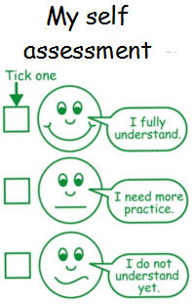
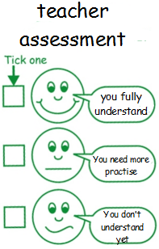

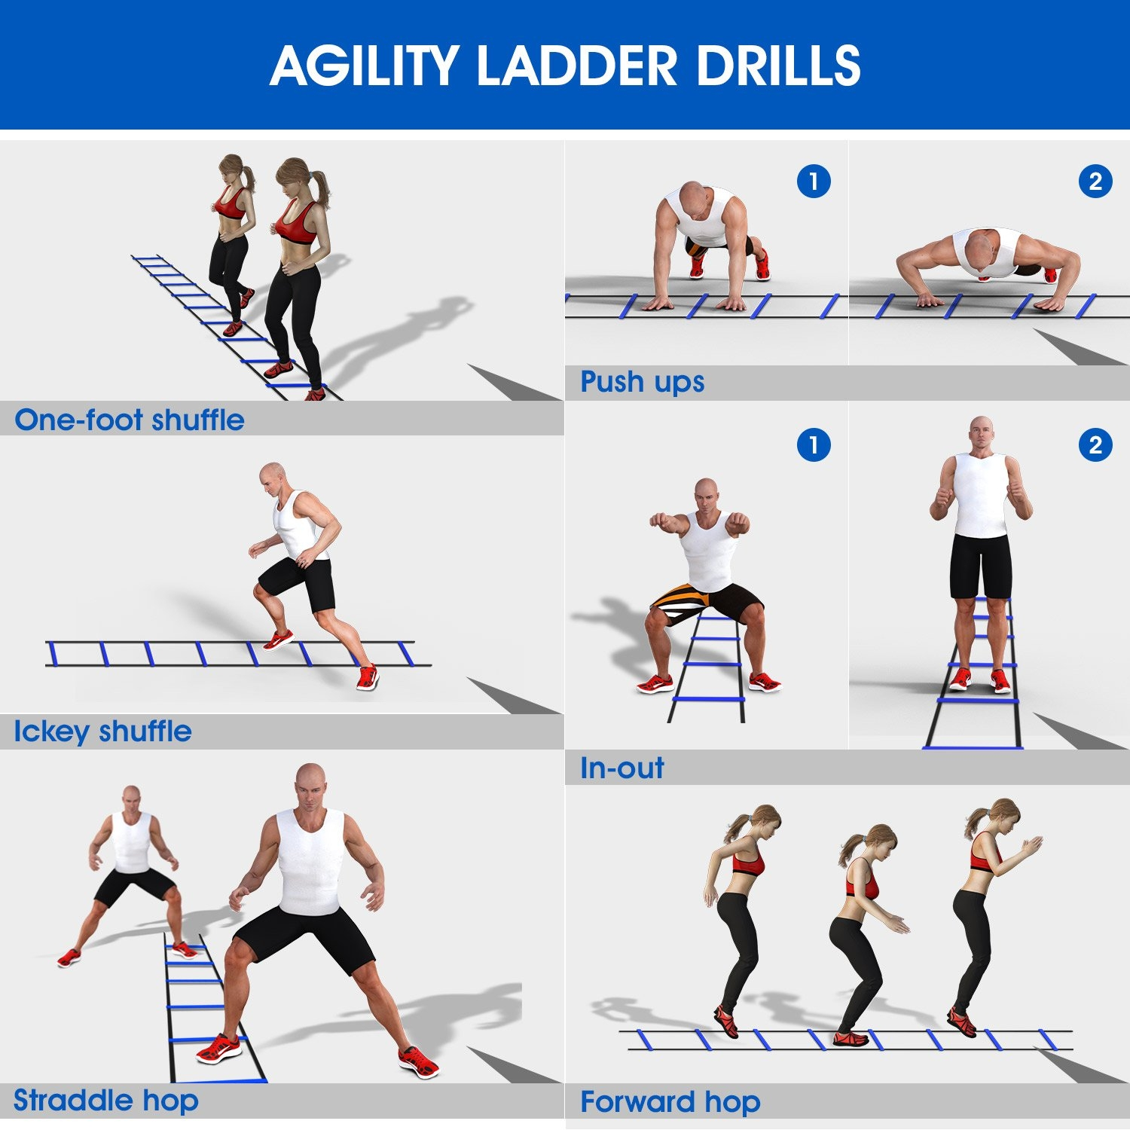

Page 2

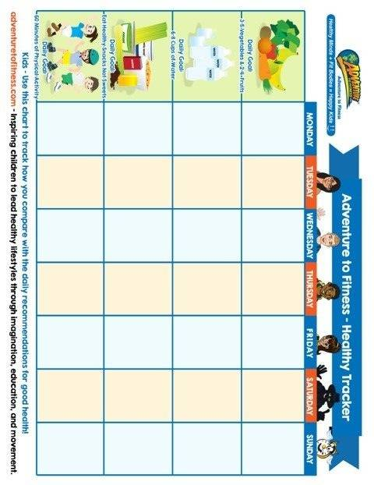

Page 3

