
PE Home Learning Pack
Dance 3 KS2
Exercise / Work out
https://www.youtube.com/watch?v=aBtP7008EfA

30 minute dance plyo workout-copy at home- enjoy and have fun!

Written task

See page 2 attachment
(Cardiovascular system)
Think about the benefits of having a good cardiovascular endurance in Dance/Sport. Try to re-write these on a piece of paper as a memory test game.



Fitness Challenge

Cardiovascular endurance-
See how many jumping jacks you can do in one minute

Record your results on a simple table and try to win the game.

Creative/Design

Write an article to your school explaining how the cardiovascular system plays an important role when performing sports.

Useful websites children could use to support learning
www.twinkl.co.uk
https://www.tes.com/teaching-resources

Useful vocabulary for written tasks
Oxygen, carbon dioxide, disease, hormones, body temperature, nutrients, removes waste, breathing, energy.

Parent comment:

Teacher comment:

My self-assessment Teacher assessment
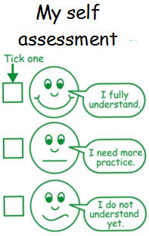
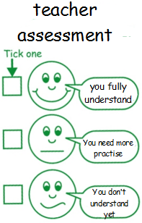

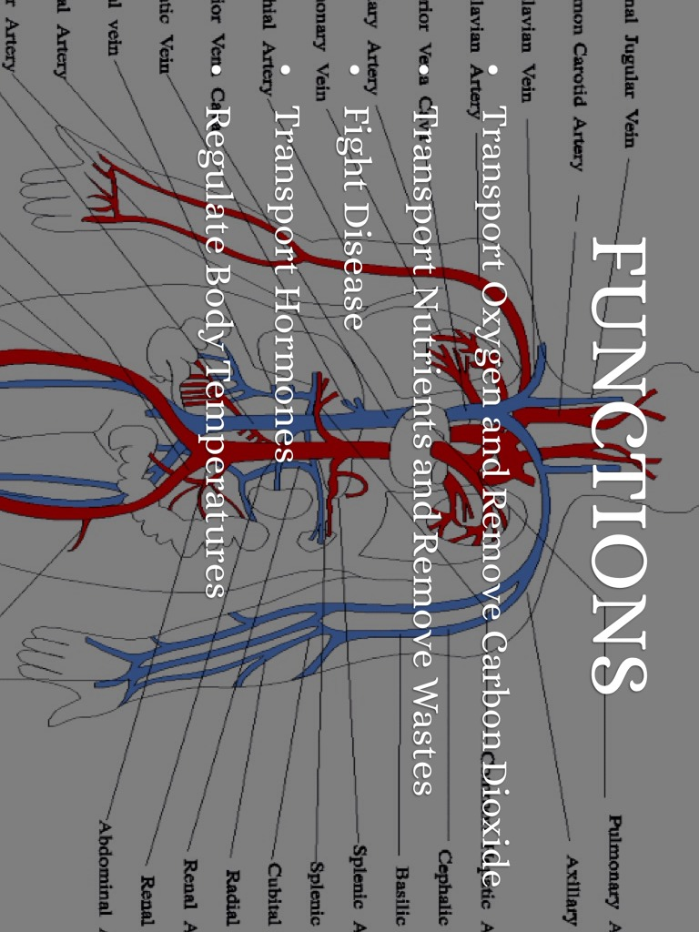

Page 2

